EEVDF Core Algorithm
Earliest Eligible Virtual Deadline First — A Complete Introduction, Mathematical Formulation, Implementation and Experiments

Eshragh Institute of Higher Education — Department of Computer Engineering
Course: Operating Systems
Student: Komeil Ramezani — ID: 1403176020
Course Instructor: Majid Shamshirgaran
November 2026

In Microsoft Word, right-click this table of contents and choose “Update Field” to refresh the page numbers after editing.

1. Introduction
A computer can only do one thing at a time on a single processor, yet it appears to do many things at once. It edits a document while it plays music, downloads a file, checks for mail, and updates the clock. The illusion is created by the CPU scheduler, the part of the operating system that decides, at every instant, which task runs next and for how long. That decision looks simple, but it is one of the hardest problems in operating systems, because two goals pull in opposite directions. The first goal is fairness: every task should receive the share of the processor it was promised, and no task should be starved. The second goal is latency: an interactive task, such as a keystroke in an editor or a frame in a video call, should be answered quickly, even when heavy batch tasks are waiting. A scheduler that is perfectly fair can still be slow to answer, and a scheduler that always answers quickly can still be unfair. The Earliest Eligible Virtual Deadline First algorithm, universally known as EEVDF, is an attempt to achieve both goals at the same time, and it is the subject of this report.
EEVDF is a proportional-share scheduler. That phrase needs to be understood before anything else. In a proportional-share system every task carries a weight, and the processor is divided in proportion to those weights. A task with weight 2 should receive twice as much processor time as a task with weight 1, over any long interval in which both tasks are competing. The idea is old, but the difficulty is in making it work tick by tick, when tasks arrive and leave at unpredictable moments, when some tasks want long uninterrupted runs and others want only a brief moment of attention, and when the scheduler must decide in a tiny fraction of a second. EEVDF solves this by giving every task two numbers that change as it runs: a virtual runtime, which records how much service the task has received after correcting for its weight, and a virtual deadline, which records when the task would finish its next requested slice in an ideal, perfectly smooth system. At each decision point the scheduler first throws out the tasks that have already received more than their fair share, and then, among the tasks that remain, it runs the one with the earliest virtual deadline. The first step protects fairness. The second step protects latency. The whole algorithm is contained in those two steps, and the whole of this report is an explanation of why they work.
This report is the student's own complete introduction to EEVDF. That sentence matters, and it must be stated plainly at the start. The folder EEVDF_Core_Algorithm in the repository https://github.com/komeil1385/EEVDF contains a file called document_english.pdf, which is 37 pages long. That file is not the student's report. It is the original research paper by Ion Stoica and Hussein Abdel-Wahab, published in 1995 as technical report TR-95-22 of Old Dominion University, and it is kept in the repository as the primary source. A student who submits the original paper as his own work has not introduced the algorithm at all. This report is therefore written from scratch, in the student's own words, on the basis of that paper, of the Linux kernel documentation, of standard operating-system textbooks, and of the student's own Python implementation and experiments in the repository. Every number in the experimental chapters comes from an actual run of that code, and where the repository's old README file disagreed with the actual run, this report says so and corrects the number, with the evidence shown.

1.1 What you will learn
By the end of this report you should be able to do seven things. First, you should be able to define every term EEVDF uses: task, arrival time, burst time, weight, time slice, virtual runtime, system virtual time, lag, eligibility, and virtual deadline. Second, you should be able to compute a virtual deadline by hand for any task, and to decide whether a task is eligible at a given moment. Third, you should be able to trace EEVDF tick by tick through a small workload, writing down the virtual time, the eligible set, and the chosen task at every tick, and to draw the resulting Gantt chart. Fourth, you should be able to read the Python implementation in the repository, explain every function, run it, and reproduce its output. Fifth, you should be able to explain, with numbers, how a change of weight or a change of slice changes the schedule. Sixth, you should be able to compare EEVDF honestly with Rate Monotonic, Earliest Deadline First, the Completely Fair Scheduler, Lottery scheduling, and Round Robin, and to say where each one is stronger and where each one is weaker. Seventh, you should be able to explain what changed in the Linux kernel in version 6.6, when EEVDF replaced the Completely Fair Scheduler, and what the pure Python model in this report leaves out of the real kernel. If you can do those seven things, you understand EEVDF well enough to use it, to teach it, and to defend it in an examination or a seminar.

1.2 How to read this report
The report is written so that it can be read in order, from the first page to the last, but it can also be used as a reference. Chapters 2 and 3 give the history and the vocabulary. If you already know what a scheduler is, you can move quickly through them, but do not skip the symbols table in Chapter 3, because the same symbols are used in every later chapter. Chapter 4 is the mathematics. It is the hardest chapter, and it is also the chapter that makes everything else make sense, because EEVDF is a mathematical idea before it is a program. Chapter 5 describes the algorithm step by step and gives the formal pseudocode and the flowchart. Chapter 6 is the Python implementation, with the complete code. Chapters 7 to 10 are the experiments: one main experiment traced in full detail, and four further experiments that each isolate one effect. Chapter 11 studies the time slice, Chapter 12 studies lag and eligibility in depth, and Chapter 13 compares EEVDF with the other schedulers. Chapter 14 explains the Linux kernel. Chapter 15 lists the strengths and the limitations and corrects six common misconceptions. Chapter 16 connects this report to the other assignments in the same repository. Chapter 17 is a set of eight exercises with full worked solutions, and Chapter 18 is the glossary, the references, and an appendix that maps every requirement of the course table to the place in this report where it is satisfied.
A note on numbers. Every table of results in Chapters 7 to 10 and 13 is an actual measured result, not a prediction and not a copy from a textbook. The workloads are defined exactly, the code that ran them is printed in full in Chapter 6, and the command used to run it is given. If you run the same code on the same workload, you will get the same numbers. That is the standard this report holds itself to, and it is why the report corrects the old README file wherever the README file was wrong. A report that cannot be reproduced is not a scientific report, and a student who discovers an error in his own earlier notes and corrects it in public is doing science correctly.

1.3 The repository map
All of the work described in this report lives in one public repository, https://github.com/komeil1385/EEVDF, on the main branch. The repository is organised into one folder per assignment, and the table below is the map you need. This report belongs to the first row of the table, the folder EEVDF_Core_Algorithm, but it refers to the other folders wherever they are relevant, and Chapter 16 explains each connection in detail.
Table 1. Repository map: one folder per assignment. This report is the documentation for EEVDF_Core_Algorithm.
Folder | Contents | Role in this report
EEVDF_Core_Algorithm | eevdf.py (116 lines), document_english.pdf (the 1995 paper), result.png, README.md | The subject of this report: the pure EEVDF implementation and the main experiment
EEVDF_vs_RM_EDF | compare_schedulers.py, result.jpg, README.md | The RM, EDF and EEVDF benchmark used in Chapter 13
EEVDF_with_Semaphore | eevdf_semaphore.py, English and Persian reports | EEVDF combined with semaphore synchronisation; see Chapter 16
EEVDF_with_Monitor | eevdf_monitor.py, English and Persian reports | EEVDF combined with monitor synchronisation; see Chapter 16
EEVDF_Semaphore_and_Monitor | eevdf_sync_comparison.py, English and Persian reports | The two synchronisation styles compared side by side; see Chapter 16
RM_EDF_Gantt_Chart | RM.jpg and EDF.jpg, handwritten Gantt charts on paper | Hand-drawn scheduling of RM and EDF with three processes; see Chapter 16
EEVDF_Animated | index.html, a 90-second interactive animation | The clip for the course: an interactive animation, not a video file; see Chapter 16
EEVDF_Simulation | index.html, script.js, style.css, tests.js | A complete interactive simulator in the browser, with passing tests; see Chapter 16
Process-Synchronization-Mechanisms | English and Persian comparison reports (57 and 56 pages) | Peterson, Dekker, semaphore, monitor, readers-writers and dining philosophers
Counter_thread_Process | Counter_thread_Process.py and a screenshot | A small system report tool; not part of the EEVDF argument

A note on the course table. The course requires, for each assignment, a figure, a flowchart, a comparison table, executable code, a clip, an English file, a Persian file, more than 40 pages, and Word and PDF versions. This English report satisfies the figure, flowchart, comparison-table, executable-code, English-file and Word requirements for the EEVDF Core Algorithm, and it is written to exceed 40 pages. The Persian version is its companion file. The clip is the interactive animation in EEVDF_Animated, and the PDF version is produced from the same Word file. The appendix in Chapter 18 maps each requirement to the exact page, figure, and table where it is met.

2. History and Context
EEVDF was not invented for the Linux kernel. It was invented in 1995, eleven years before the kernel even had the scheduler it would eventually replace, and it was invented to solve a problem that had nothing to do with Linux. Ion Stoica and Hussein Abdel-Wahab, at the Department of Computer Science of Old Dominion University in Norfolk, Virginia, were studying proportional-share resource allocation in general: how to divide a single shared resource, such as a processor or a network link, among competing clients, in proportion to the weights those clients hold, and how to do it accurately, tick by tick, when clients arrive, leave, and change their weights at any moment. Their paper, Earliest Eligible Virtual Deadline First: A Flexible and Accurate Mechanism for Proportional Share Resource Allocation, was published as technical report TR-95-22 and revised in January 1996. It is the founding document of EEVDF, and it is the document_english.pdf file in the repository. Everything in this report that is a theorem, a definition, or a bound comes from that paper, and everything that is an experiment comes from the student's own code.
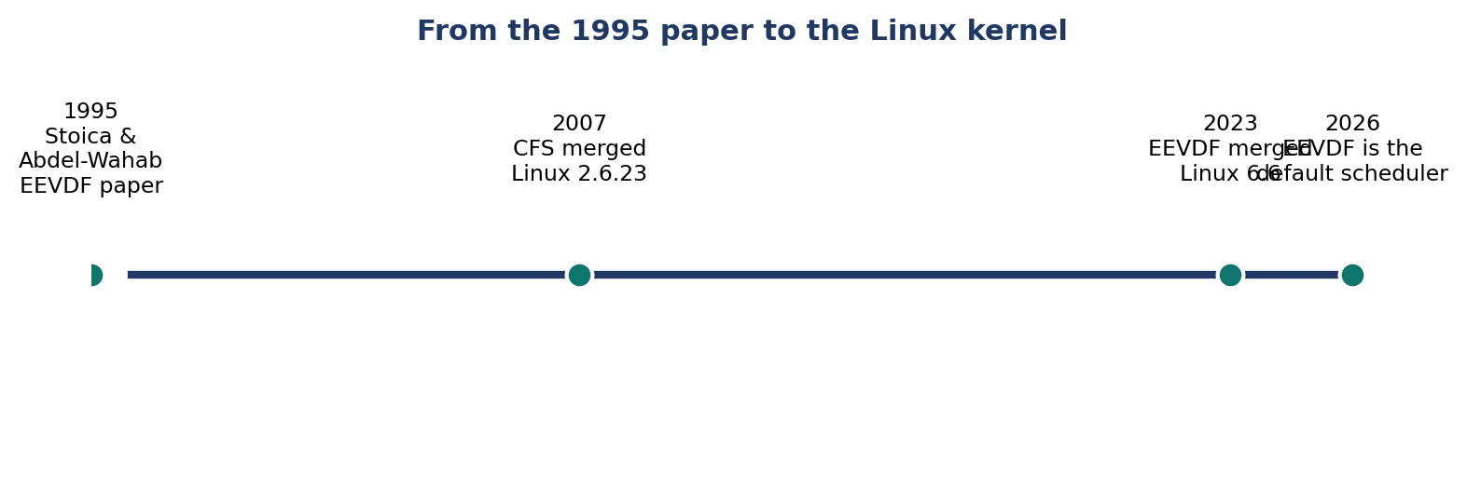
Figure 1. From the 1995 paper to the Linux kernel: EEVDF was published in 1995, CFS was merged in 2007, and EEVDF itself was merged in 2023 and has been the default scheduler since Linux 6.6.
To understand why a 1995 paper became the Linux scheduler in 2023, it helps to know what came between. In the early years of Linux, the scheduler was a relatively simple priority scheduler. It worked, but it did not scale well, and it did not treat interactive tasks fairly. In 2007, with Linux 2.6.23, Ingo Molnar merged the Completely Fair Scheduler, universally known as CFS. CFS was a great step forward. Its central idea was virtual runtime, written vruntime: every task accumulates vruntime as it runs, corrected for its weight, and the scheduler always runs the task with the smallest vruntime. In a perfectly fair world, all tasks would have equal vruntime, and CFS moves the system towards that equality. For sixteen years CFS was the default scheduler of Linux, and it served the kernel well. But CFS had a weakness that became harder to ignore as workloads changed. Because CFS only looks at vruntime, it has no direct way to say that one task wants a short slice and should therefore be answered quickly, while another task wants a long slice and can wait. A task that asks for a long slice and a task that asks for a short slice are treated the same way if their vruntime is the same, and the result is that interactive tasks can wait longer than they should. Several researchers and kernel developers proposed fixes, and the most principled of them was to return to the 1995 paper and to use its two ideas, eligibility and the virtual deadline, which CFS had never used.
The return to EEVDF was led in the kernel by Peter Zijlstra, and the work was merged in Linux 6.6, released in October 2023. From that version onwards, EEVDF is the default scheduler for normal tasks on Linux, and CFS, as a separate scheduler, is gone. The code lives in the kernel file kernel/sched/fair.c, and the design is documented in Documentation/scheduler/sched-eevdf.rst. The merge was not a sudden revolution. The kernel developers kept the parts of CFS that worked, including vruntime and the red-black tree of runnable tasks, and they added the eligibility test and the virtual deadline on top of them. The result is a scheduler that behaves like CFS when all tasks want the same thing, and behaves better than CFS when they do not, because a task that wants a short slice now receives an early virtual deadline and is therefore chosen sooner. Chapter 14 explains the kernel version in detail, including the parts that the pure Python model in this report does not contain. For now, the important point is the timeline: a paper from 1995, a scheduler from 2007, and a merger in 2023. EEVDF is simultaneously one of the oldest and one of the newest ideas in the Linux kernel.
There is a second piece of context, and it is the reason this report exists as a university assignment rather than as a piece of kernel documentation. The course is Operating Systems, and the course table asks each student to take one algorithm as his own, to introduce it completely, to compare it with the classical algorithms, to implement it, to draw its scheduling on paper, and to present it as a clip, an article, and a seminar. The student's algorithm is EEVDF. That is why the repository contains not only the core implementation but also a comparison with Rate Monotonic and Earliest Deadline First, a semaphore version, a monitor version, a handwritten Gantt chart of RM and EDF, an animated explainer, and an interactive simulation. Each of those pieces answers one row of the course table, and each of them is described in Chapter 16. The present report answers the first row: a complete introduction to the student's own algorithm. It is written so that a reader who has never heard of EEVDF can start at the beginning and finish with a working understanding, and so that an examiner can check every claim against the code and the numbers.
Why 1995 matters. EEVDF is often described as new because it entered Linux in 2023, but its mathematics is thirty years old and has been analysed, proved, and cited for three decades. That is a strength, not a weakness: when this report states a bound on lag, or a complexity of O(log n), it is reporting a proved result, not a guess from a single experiment. The experiments in Chapters 7 to 10 illustrate the theory on small workloads; they do not replace it.

3. Basic Concepts
Every science begins with its vocabulary, and EEVDF has a small vocabulary that must be learned exactly, because the algorithm is nothing more than the interaction of its terms. This chapter defines each term, gives its formula where it has one, and gives a small numeric example for each. The symbols table at the end of the chapter collects every symbol in one place. If a later chapter uses a symbol you do not recognise, return to this table first.

3.1 Task, arrival time, and burst time
A task is a unit of work that wants the processor. In the operating system it may be a process or a thread; in this report the two words are used in the same sense, and the code calls every unit a Task. Each task has an arrival time, written a with a subscript for the task, which is the time at which the task becomes ready to run. A task that has not yet arrived cannot be scheduled, and a task that has finished cannot be scheduled again. Each task also has a burst time, written C or burst, which is the total amount of processor time the task needs before it finishes. Burst time is measured in the same units as the clock. In the pure model of this report the clock moves in integer ticks, and a burst of 4 means the task needs four ticks. In the real kernel the units are nanoseconds, but the idea is the same. A task's remaining time is its burst time minus the time it has already received. When the remaining time reaches zero, the task is complete, and its completion time, also called its finish time, is recorded.
Example. A task T1 arrives at time 0 and has a burst of 4. It needs four ticks. If it runs at times 0, 4, 6, and 8, it finishes at time 9, because the tick that starts at time 8 ends at time 9. That distinction between the time a tick starts and the time it ends is the source of many small errors in student traces, and this report is careful about it throughout: the timeline lists the task that runs in the interval from t to t + 1, and the finish time is the end of the last interval. Three further quantities are defined from arrival and finish. The turnaround time of a task is its finish time minus its arrival time: how long the task spent in the system from arrival to completion. The waiting time is its turnaround time minus its burst time: how long it spent in the system without running. The response time is the time of its first run minus its arrival time: how long it waited before it was first answered. These three numbers, and their averages over all tasks, are the metrics used in every experiment in this report.

3.2 Weight and proportional share
A weight, written w with a subscript for the task, is a positive number that states how large a share of the processor the task should receive. Weights are relative, not absolute. If two tasks have weights 1 and 1, they should each receive half of the processor. If they have weights 2 and 1, the first should receive two-thirds and the second one-third. If they have weights 2 and 2, they should each receive half again, because doubling both weights changes nothing. The ideal share of task i is its weight divided by the sum of the weights of all competing tasks. That single sentence is the whole meaning of proportional share, and every other definition in EEVDF exists to make that sentence true tick by tick rather than only on average over a long time.
Example. Three tasks have weights 1, 2, and 3. The sum of the weights is 6. Their ideal shares are 1/6, 2/6, and 3/6, which is 16.7 percent, 33.3 percent, and 50 percent. Over 60 ticks in which all three are competing, the first should receive about 10 ticks, the second about 20, and the third about 30. In the Linux kernel, weights come from the nice value of a task through a fixed table, so a user who changes a nice value is changing a weight. In the pure model of this report, weights are chosen directly in the workload, so that the effect of a weight can be studied in isolation. Experiment C in Chapter 9 is exactly that study: the same burst for three tasks, weights 2, 1, and 1, and the task with weight 2 finishes first.

3.3 Time slice, quantum, and request
A time slice, written r with a subscript for the task, is the amount of processor time the task asks for in one request. It is also called a quantum, and the two words are used interchangeably in this report. The slice is not the same as the burst. The burst is the total work the task needs. The slice is the size of the piece it asks for at a time. A batch task that wants to run for a long time asks for a long slice, for example 4 or 6. An interactive task that wants only a quick answer asks for a short slice, for example 1. The distinction is the key to latency in EEVDF: the scheduler does not need to be told that a task is interactive. It only needs to see that the task asks for a short slice, and it will give that task an early virtual deadline, as Chapter 5 explains. In the code, the slice is stored in the field called slice, and the value passed to the Task constructor as time_slice. In the original paper, a request is a demand for one quantum of service, and the client issues a new request each time it wants another quantum. This report uses the word request in that sense, and the word slice for the size of the request.
Example. A task with weight 1 asks for a slice of 4, and a task with weight 2 asks for a slice of 1. The first task is saying, in effect, give me a long run. The second is saying, give me a short run, and give it to me soon. EEVDF hears both requests through the virtual deadline, which is the subject of Section 3.7. The numbers are small, but the principle is the same in the kernel, where a task that wakes up and asks for a short run is treated as latency-sensitive, and a task that runs for a long time is treated as a batch task.

3.4 Virtual runtime
Virtual runtime, written vruntime, is the most important quantity in EEVDF, and also the easiest to misunderstand. It is not the time a task has spent running. It is the time a task has spent running, corrected for its weight. Each time a task runs for a small interval of real time, written delta t, its vruntime increases by delta t divided by its weight. The formula is vruntime_new = vruntime_old + delta t / w_i. A task with weight 1 that runs for one tick gains 1.0 of vruntime. A task with weight 2 that runs for one tick gains only 0.5. The heavier task is charged less for the same real time, because it is entitled to more real time. That is the whole trick: by measuring service in virtual time instead of real time, the scheduler can compare tasks with different weights on a single scale. If two tasks have the same vruntime, they have received the same fair share, even if one of them has run for twice as many real ticks as the other.
Example. Task A has weight 1 and runs for 2 ticks. Its vruntime rises from 0 to 2. Task B has weight 2 and runs for 2 ticks. Its vruntime rises from 0 to 1. Task B has run for the same real time, but it has consumed only half as much virtual time, because it is entitled to twice as much real time. If the scheduler always runs the task with the smallest vruntime, as CFS does, it will now prefer Task B, because B's vruntime is smaller. That is correct: B is owed more service. Work through this example with a pencil before reading on, because every trace in Chapters 7 to 10 depends on it. In the code, vruntime starts at 0.0 for every task, and the line selected.vruntime += 1.0 / selected.weight is the only place it ever changes. One tick of real time, one update, and the update is divided by the weight.

3.5 System virtual time
System virtual time, written V with an overline in the paper and called V or avg_vruntime in this report and in the code, is the weighted average of the vruntime of the active tasks. The formula is V = sum(w_i * vruntime_i) / sum(w_i), where the sums run over the tasks that are active at the current moment, meaning tasks that have arrived and have not yet finished. System virtual time is the scheduler's picture of where the system as a whole has reached. A task whose vruntime is below V has received less than the average fair share. A task whose vruntime is above V has received more. The average is weighted, not simple, because a heavy task counts more in the average than a light task. If the average were simple, a single heavy task with a large vruntime could be outvoted by many light tasks, and the picture would be wrong. The weighted average is the correct picture, and it is the number against which eligibility is judged.
Example. Two tasks are active. T1 has weight 1 and vruntime 1.0. T2 has weight 2 and vruntime 0.0. The weighted average is (1 * 1.0 + 2 * 0.0) / (1 + 2) = 1/3, which is about 0.33. The simple average would be 0.5, which would overstate how far the system has advanced, because the task that has advanced furthest, T1, is the lighter task. Now add a third task, T3, with weight 2 and vruntime 0.5. The weighted average becomes (1 * 1.0 + 2 * 0.0 + 2 * 0.5) / (1 + 2 + 2) = 2/5 = 0.40. Work this example out by hand as well. It is the calculation the code performs at every tick, in the line avg_vruntime = sum(t.vruntime * t.weight for t in active_tasks) / total_weight, and it is the first thing the scheduler computes after it has found the active tasks.

3.6 Lag and eligibility
Lag is the difference between the service a task should have received in an ideal fluid system and the service it actually received. In symbols, Lag_i(t) = S_i(t) - s_i(t), where S_i(t) is the ideal service and s_i(t) is the actual service, both measured up to time t. A task with positive lag is behind: it should have received more than it did. A task with negative lag is ahead: it received more than it should have. A task with zero lag is exactly on schedule. In the implementation, lag is not computed from S_i and s_i directly. It is computed from vruntime and system virtual time, by the equivalent formula lag_i = (V - vruntime_i) * w_i. The two formulas say the same thing in different units: the first measures lag in real service time, and the second measures it in virtual time multiplied by weight. A task is eligible to run if and only if its lag is greater than or equal to zero, which is the same as saying its vruntime is less than or equal to V. That is the eligibility rule, and it is the first of the two decisions EEVDF makes. It is a filter. It removes from consideration every task that has already had more than its fair share, no matter how urgent that task claims to be, and it keeps every task that is behind or on schedule.
Example. At some moment V is 0.5. Task T1 has weight 1 and vruntime 1.0, so its lag is (0.5 - 1.0) * 1 = -0.5. It is ahead, and it is not eligible. Task T2 has weight 1 and vruntime 0.0, so its lag is (0.5 - 0.0) * 1 = 0.5. It is behind, and it is eligible. Task T3 has weight 2 and vruntime 0.5, so its lag is (0.5 - 0.5) * 2 = 0.0. It is exactly on schedule, and it is eligible, because the rule is lag greater than or equal to zero, not strictly greater. In the code, this is the loop that sets t.lag = (avg_vruntime - t.vruntime) * t.weight and keeps the task if t.vruntime <= avg_vruntime. The equality case matters, and students who write a strict inequality lose it. A task that is exactly on schedule must be allowed to run, or the system can stall when all tasks are exactly on schedule.
Eligibility is what makes EEVDF different from EDF, and it is worth pausing on the difference, because it is the most common source of confusion. Earliest Deadline First chooses the task with the earliest absolute deadline, with no filter at all. If a task has already received more than its fair share but happens to have an early deadline, EDF will run it again, and the task that is behind will wait. EEVDF refuses to do that. It first asks who is behind, and only then asks who has the earliest deadline. The filter is what guarantees fairness, and the deadline is what guarantees latency. Neither step alone is enough, and the order matters: filter first, then choose by deadline. Chapter 12 works through the cases in which a task is ineligible, what happens to it, and what the code does when no task at all is eligible.

3.7 Virtual deadline
The virtual deadline, written v_deadline, is the virtual time at which a task would finish its current request if the system were perfectly smooth. The formula is v_deadline = vruntime_i + r_i / w_i, where r_i is the requested slice and w_i is the weight. Read the formula slowly. It starts from where the task is now, its vruntime, and it adds the cost of the request, which is the slice divided by the weight. A long slice adds a large amount, so the deadline is far away. A short slice adds a small amount, so the deadline is near. A large weight divides the slice by a large number, so the deadline is nearer than it would be for a light task asking for the same slice. The virtual deadline is therefore a single number that combines three facts about a task: how much it has already received, how much it is asking for now, and how heavy it is. The scheduler chooses the eligible task with the smallest virtual deadline. That task is, in the precise sense of the formula, the task whose next piece of work would finish earliest in the ideal system.
Example. Three tasks all have vruntime 0. T1 has weight 1 and asks for a slice of 4, so its virtual deadline is 0 + 4/1 = 4. T2 has weight 1 and asks for a slice of 4, so its virtual deadline is also 4. T3 has weight 2 and asks for a slice of 1, so its virtual deadline is 0 + 1/2 = 0.5. T3 is chosen first, by a large margin, even though it arrived later than T1 and T2 in the main experiment. It is chosen because it asks for little and it is heavy. Now change the example: suppose T3 has weight 1 instead of 2, and still asks for a slice of 1. Its virtual deadline is 0 + 1/1 = 1, which is still earlier than 4, so it is still chosen first, but by a smaller margin. The slice alone is enough to make it win. Now suppose T3 has weight 2 and asks for a slice of 4. Its virtual deadline is 0 + 4/2 = 2, which is still earlier than 4, so it still wins, but now because of its weight. These three small calculations contain the whole intuition of Chapter 11: the slice controls latency, the weight controls share, and the virtual deadline combines them.

3.8 The symbols table
The table below collects every symbol used in this report. Keep it open while you read Chapters 4 and 5. The same letters are used in the paper, in the kernel documentation, and in the code, except that the code spells the names out in full, as vruntime, v_deadline, and lag, because a program cannot use subscripts.
Table 2. Symbols used in this report, in the 1995 paper, and in the code.
Symbol | Name | Meaning | Unit
i | Task index | Which task is meant: T1, T2, T3 | -
a_i | Arrival time | Time at which task i becomes ready | ticks
C_i | Burst time | Total processor time task i needs | ticks
w_i | Weight | Relative share task i should receive | -
r_i | Time slice / quantum | Processor time task i asks for in one request | ticks
vruntime_i | Virtual runtime | Service received, corrected for weight | virtual time
V | System virtual time | Weighted average of vruntime over active tasks | virtual time
Lag_i(t) | Lag | Ideal service minus actual service at time t | time
lag_i | Lag (implementation) | (V - vruntime_i) * w_i; eligible iff lag_i >= 0 | time
v_deadline_i | Virtual deadline | vruntime_i + r_i / w_i | virtual time
S_i(t) | Ideal service | Service task i would receive in a fluid system | time
s_i(t) | Actual service | Service task i has actually received | time
q | Quantum size | Largest time quantum in the system; lag is bounded by q | ticks
n | Number of tasks | How many tasks are competing | -

Two warnings about the symbols will save the reader from the two most common mistakes. First, vruntime and real time are different quantities, and they are measured in different units. A task can have a small vruntime and a large real runtime, if it is heavy, and it can have a large vruntime and a small real runtime, if it is light. Never compare a vruntime with a clock time. Second, the virtual deadline is not a real deadline. No task misses a virtual deadline in the way a real-time task misses a real deadline, and no penalty follows from passing it. The virtual deadline is an ordering key: it says which task goes first, and nothing more. Chapter 15 returns to both mistakes, because they are the source of the most persistent misconceptions about EEVDF.

4. Mathematical Formulation
The mathematics of EEVDF begins with a system that does not exist: the ideal fluid system. Imagine a processor that can be divided into arbitrarily small pieces, so that two tasks can each receive half of the processor at the same instant, and three tasks can receive one-third each, and so on. In such a system there is no scheduling decision to make, because every task runs all the time, at a rate proportional to its weight. If tasks have weights 1 and 2, the first runs at one-third of the speed of a dedicated processor, and the second runs at two-thirds, continuously, without interruption. The fluid system is the standard against which every real scheduler is measured. It is perfectly fair by construction, and it is the definition of what fair means. The real system, by contrast, can only give the whole processor to one task at a time, in quanta. The question EEVDF answers is how close a real system can come to the fluid system, and the answer is: closer than one quantum.

4.1 Ideal service and actual service
For each task i and each time t, define S_i(t) as the service the task would have received by time t in the ideal fluid system, and s_i(t) as the service it has actually received in the real system. Both are measured in real time. In the fluid system, if task i is active throughout the interval from 0 to t, and the set of active tasks does not change, then S_i(t) is t multiplied by the task's ideal share, which is w_i divided by the sum of the weights of the active tasks. If the set of active tasks changes, because a task arrives or leaves, then S_i(t) is the integral of the ideal share over time, which is the same idea applied piece by piece. The actual service s_i(t) is simpler: it is the total number of ticks the task has actually run up to time t. The difference between the two, Lag_i(t) = S_i(t) - s_i(t), is the lag defined in Chapter 3. A positive lag means the task is owed service. A negative lag means it has been given more than its ideal share. A lag of zero means the real system has matched the ideal system exactly for that task up to time t.
Worked example. Two tasks, A and B, both arrive at time 0, with weights 1 and 1. The ideal share of each is one-half. After 10 units of time, each should have received 5 units of service in the fluid system, so S_A(10) = 5 and S_B(10) = 5. Suppose the real scheduler ran A for 6 ticks and B for 4 ticks in those 10 units. Then s_A(10) = 6 and s_B(10) = 4. The lags are Lag_A(10) = 5 - 6 = -1, and Lag_B(10) = 5 - 4 = +1. A is one unit ahead, and B is one unit behind, and the lags sum to zero, as they must, because the total service given out is the same in both systems. Now suppose the weights are 2 and 1 instead. The ideal shares are two-thirds and one-third, so after 9 units S_A(9) = 6 and S_B(9) = 3. If the real scheduler ran A for 7 ticks and B for 2, the lags are Lag_A(9) = 6 - 7 = -1, and Lag_B(9) = 3 - 2 = +1. Again they sum to zero. That is a general fact, and it is worth remembering: lag is a conserved quantity across the active tasks, because the processor is never idle in these examples and the total service is fixed. When one task is ahead, another must be behind.

4.2 The lag bound: at most one quantum
The central theorem of the 1995 paper is the lag bound. In steady conditions, meaning when the set of competing tasks and their weights do not change, EEVDF guarantees that the difference between the service a task should have received and the service it actually received is bounded by the size q of one time quantum. In symbols, the absolute value of Lag_i(t) is at most q. The bound is the reason EEVDF is described as accurate. A scheduler that only guarantees fairness on average, over a long time, might let a task fall behind by a large amount and then catch up later. EEVDF does not allow that. No task is ever more than one quantum behind, and no task is ever more than one quantum ahead, in steady state. The proof in the paper works by showing that the eligibility rule prevents a task from running when it is ahead, and the virtual deadline prevents a task that is behind from waiting too long, and the two rules together keep every task within one quantum of the ideal. The full proof is technical and uses the properties of the augmented binary search tree described in Section 4.4, and this report does not reproduce it line by line. What matters for the student is to understand what the bound means in practice, and to see it in the experiments.
What the bound means in practice can be seen in Workload A. The quantum size in the pure model is one tick, because the scheduler decides once per tick. The bound therefore says that no task should be more than about one tick away from its ideal service in steady state. Look at the trace in Chapter 7. At time 5, T1 has vruntime 2.0 and T2 has vruntime 1.0, and the system virtual time is 1.5. T1 is ahead by half a unit of virtual time, and T2 is behind by half a unit. Neither is far from the average. At no point in the trace does a task run away from the others. Contrast that with a naive Round Robin scheduler, which would run T1 for four ticks, then T2 for four ticks, then T3 for two ticks, and would leave T3 waiting until time 8 even though it arrived at time 1 and only wanted two ticks. Round Robin has no lag bound in this sense, and the waiting time of T3 shows it. The bound is also the reason EEVDF degrades gracefully under overload. When the system is overloaded, every scheduler must disappoint somebody, but EEVDF disappoints everybody by at most one quantum, instead of letting one task fail completely while another succeeds. Chapter 13 returns to overload behaviour when it compares EEVDF with RM and EDF.

4.3 Fairness, step by step
Fairness in EEVDF is not a slogan. It is a sequence of three precise steps, and each step can be checked. First, the scheduler measures how much each task has received, in virtual time, which corrects for weight. Second, it computes the average of those measurements, which is the system's picture of the fair position. Third, it refuses to run any task that is ahead of that average. That refusal is the whole of fairness in EEVDF, and it is enforced at every tick, not merely on average. The virtual deadline then decides, among the tasks that pass the filter, which one runs, and it does so in a way that also respects fairness, because the deadline is built from vruntime and from the requested slice divided by the weight. A task that has received little has a small vruntime and therefore a small deadline, and a task that asks for little also has a small deadline, and a task that is heavy has its slice divided by a large weight, so its deadline is smaller than a light task asking for the same slice. Every term in the formula pushes in the direction of fairness, and no term pushes against it. That is why the algorithm can be described in one sentence, and why that sentence is worth memorising: among the tasks that are not ahead, run the one whose next piece of work would finish earliest in the ideal system.
It is also worth stating what fairness does not mean. Fairness does not mean equal service. Equal service would be correct only if all weights were equal, and in general they are not. Fairness means service in proportion to weight, and a task with weight 2 that receives twice as much as a task with weight 1 is being treated fairly, not unfairly. Fairness does not mean that every task finishes at the same time. A task with a long burst will finish later than a task with a short burst, even if both are treated fairly, because it has more work to do. And fairness does not mean that no task ever waits. Every task waits when the processor is busy. Fairness means that the waiting is distributed in proportion to the weights and the work, and that no task waits because another task has taken more than its share. The metrics in the experiments measure exactly that: waiting time, turnaround time, and response time, and the averages of those three numbers, for each workload, so that the reader can judge for himself whether the distribution is fair.

4.4 The data structure: an augmented tree in O(log n)
A scheduler must be fast. It runs at every tick, and often many times per second, and it cannot afford to scan the whole runqueue to find the next task. EEVDF, as described in the 1995 paper, stores the pending requests in an augmented binary search tree, keyed by virtual eligible time, which is the virtual time at which a request becomes eligible. Each node of the tree stores, in addition to its own key, the minimum virtual deadline in its subtree, so that the scheduler can find the eligible request with the earliest virtual deadline by walking down the tree, choosing at each step the child whose subtree contains the smallest deadline. The operations the scheduler needs are insertion of a new request, deletion of a request that has been served, and search for the eligible request with the earliest deadline. Each of those operations takes O(log n) time, where n is the number of competing clients, because each step down the tree halves the number of candidates. The paper also shows that dynamic operations, such as a client joining the competition, leaving it, or changing its weight, can be implemented in the same O(log n) time. That is the complexity claim of EEVDF, and it is the same order of complexity as the red-black tree used by CFS and by the Linux implementation of EEVDF, which stores runnable tasks in a red-black tree keyed by vruntime.
The pure Python model in this report does not use a tree. It uses a list, and at every tick it scans the list to compute the average, to filter the eligible tasks, and to find the smallest virtual deadline. That is O(n) per tick, not O(log n), and it is slower. The difference does not matter for the workloads in this report, which have two or three tasks, but it would matter for a system with thousands of tasks, and it is one of the differences between the pure model and the kernel that Chapter 14 lists. The student should understand the distinction and be able to state it in an examination: the algorithm is O(log n) with the tree, and the Python teaching implementation is O(n) because it uses a list for clarity. Clarity is the right choice for a teaching implementation, and speed is the right choice for a kernel, and the two are not in conflict, because the algorithm and its data structure are separate things.

4.5 Derivation in five steps
- Start from the fluid system. Define ideal service S_i(t) as the integral of the ideal share w_i / sum(w_j) over time. In the fluid system every task receives its share continuously, and lag is zero for every task at every moment.
- Quantise the fluid system. The real system can only give the whole processor to one task for one quantum q at a time. Each grant of a quantum moves one task ahead of the fluid system by at most q, and leaves the others behind by the corresponding amount.
- Measure the error in virtual time. Define vruntime_i as the service received divided by the weight, so that tasks with different weights can be compared. Define V as the weighted average of vruntime. Then lag_i = (V - vruntime_i) * w_i measures, in real time, how far task i is from the fluid position.
- Filter by eligibility. Allow only tasks with lag_i >= 0, that is vruntime_i <= V, to be considered. This prevents any task from moving further ahead than the fluid system, and it is the step that enforces the lag bound.
- Order by virtual deadline. For each eligible task, compute v_deadline_i = vruntime_i + r_i / w_i, and run the task with the smallest value. This is the request that would finish earliest in the fluid system, so running it first keeps the real system as close as possible to the fluid system, and it gives short requests an early finish, which is low latency.
That is the whole derivation. It starts from a definition of fairness, it measures the distance from that definition, it forbids the scheduler from increasing the distance, and it chooses, among the moves that do not increase it, the one that finishes earliest in the ideal system. The rest of this report is the working out of those five steps in code, in traces, and in experiments.

5. How EEVDF Works, Step by Step
This chapter describes the algorithm as a procedure that can be followed by hand. It gives the architecture, the flowchart, the step-by-step procedure, and the formal pseudocode. If you can follow this chapter with a pencil and a small workload, you can follow every experiment that comes after it, because the experiments are nothing more than this procedure repeated, tick after tick.
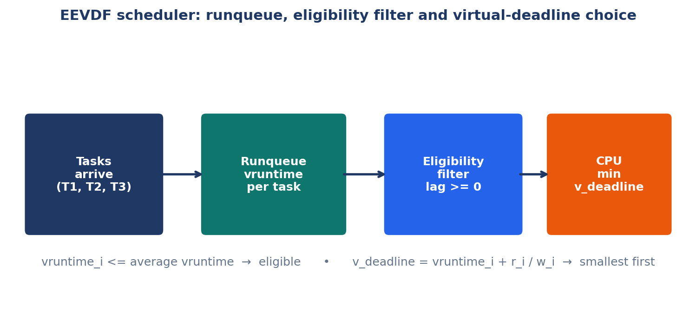
Figure 2. Architecture of the EEVDF scheduler: tasks arrive into the runqueue, the eligibility filter keeps only tasks with lag >= 0, and the CPU is given to the eligible task with the smallest virtual deadline.
The architecture has four parts, and they appear in the figure in the order in which the scheduler uses them. First, tasks arrive and join the runqueue. Each task in the runqueue carries its vruntime, its weight, its slice, and its remaining time. Second, the scheduler computes the system virtual time V, the weighted average of vruntime over the active tasks in the runqueue. Third, the eligibility filter keeps only the tasks whose vruntime is less than or equal to V, which is the same as keeping only the tasks whose lag is greater than or equal to zero. Fourth, the scheduler computes the virtual deadline of each surviving task and gives the CPU to the one with the smallest value. The task runs for one tick, its vruntime increases by 1 / w, its remaining time decreases by 1, and the whole procedure repeats at the next tick. There is no other state, no other queue, and no other decision. The simplicity is deliberate, and it is the reason the algorithm can be proved correct and can be implemented in a kernel.
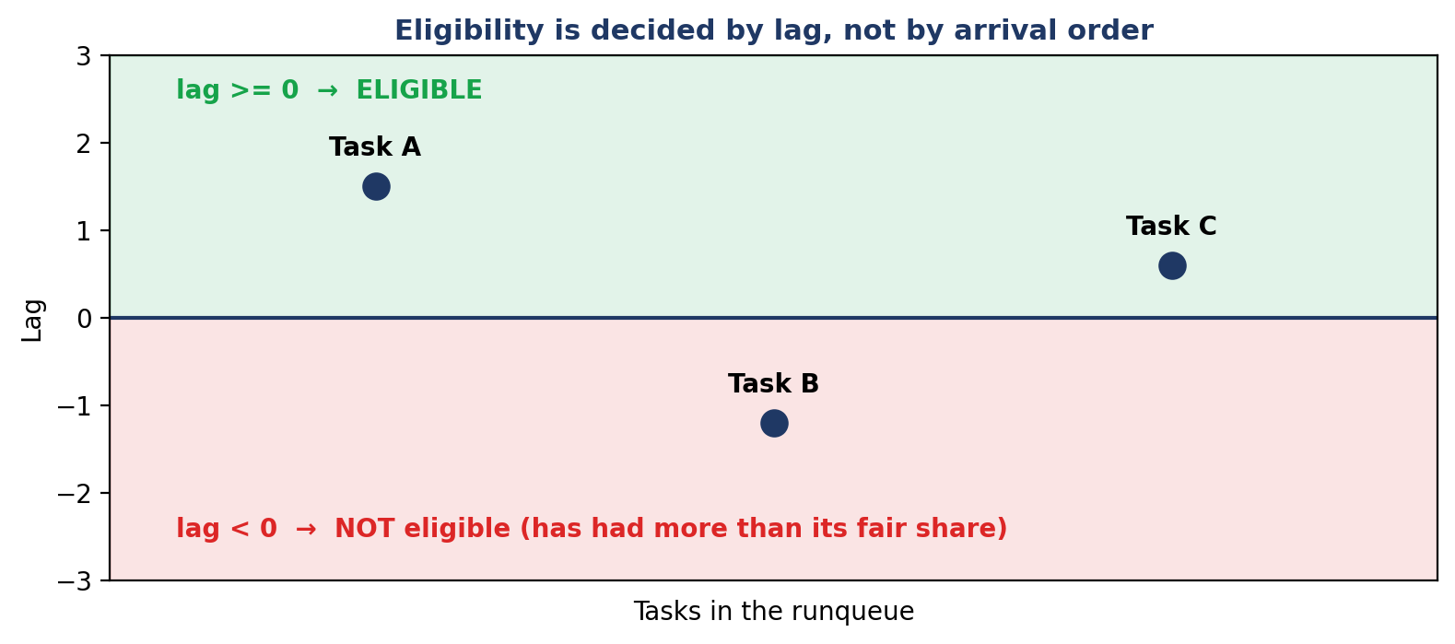
Figure 3. Eligibility is decided by lag, not by arrival order. A task with lag >= 0 is eligible; a task with lag < 0 has had more than its fair share and must wait.

5.1 The procedure, tick by tick
- Find the active tasks. An active task is one that has arrived, so arrival <= current time, and has not finished, so remaining > 0. If there is no active task, the CPU is idle for one tick, the clock advances by one, and the procedure repeats.
- Compute the system virtual time V. Add up w_i * vruntime_i over all active tasks, and divide by the sum of the weights. That is the weighted average, and it is the fair position of the system at this moment.
- Compute the lag of each active task. For each active task, lag_i = (V - vruntime_i) * w_i. This number is positive for a task that is behind, negative for a task that is ahead, and zero for a task that is exactly on schedule.
- Filter by eligibility. Keep the tasks with vruntime_i <= V, equivalently lag_i >= 0. Discard the rest for this tick. They are not punished, and they are not forgotten; they will be reconsidered at the next tick, when V has moved.
- Handle the empty case. If no task is eligible, which can happen only when the arithmetic of the filter leaves the set empty, fall back to all active tasks. This rule is in the code, and it guarantees that the scheduler never stalls when there is work to do. In the workloads of this report the fallback is never needed, because at least one task is always eligible, but the rule must be present for correctness in general.
- Compute the virtual deadline of each eligible task. For each eligible task, v_deadline_i = vruntime_i + r_i / w_i. The slice r_i is the slice the task requested, and the weight w_i is the task's weight. A short slice and a large weight both make the deadline earlier.
- Choose the smallest virtual deadline. Sort the eligible tasks by virtual deadline, smallest first, and break ties by arrival time, earliest first. The first task in that order is the chosen task. If two tasks have the same deadline and the same arrival time, the order in the runqueue decides, and the choice is still deterministic.
- Run the chosen task for one tick. Append its name to the timeline. Decrease its remaining time by 1. Increase its vruntime by 1 / w_i. Advance the clock by 1. If this is the first time the task has run, record the current time as its first run time.
- Check for completion. If the chosen task's remaining time is now zero, mark it complete and record the current time as its finish time. Otherwise, leave it in the runqueue for the next tick.
- Repeat. Go back to step 1. Stop when every task is complete. The timeline, the finish times, and the metrics are then computed from the recorded first-run and finish times.
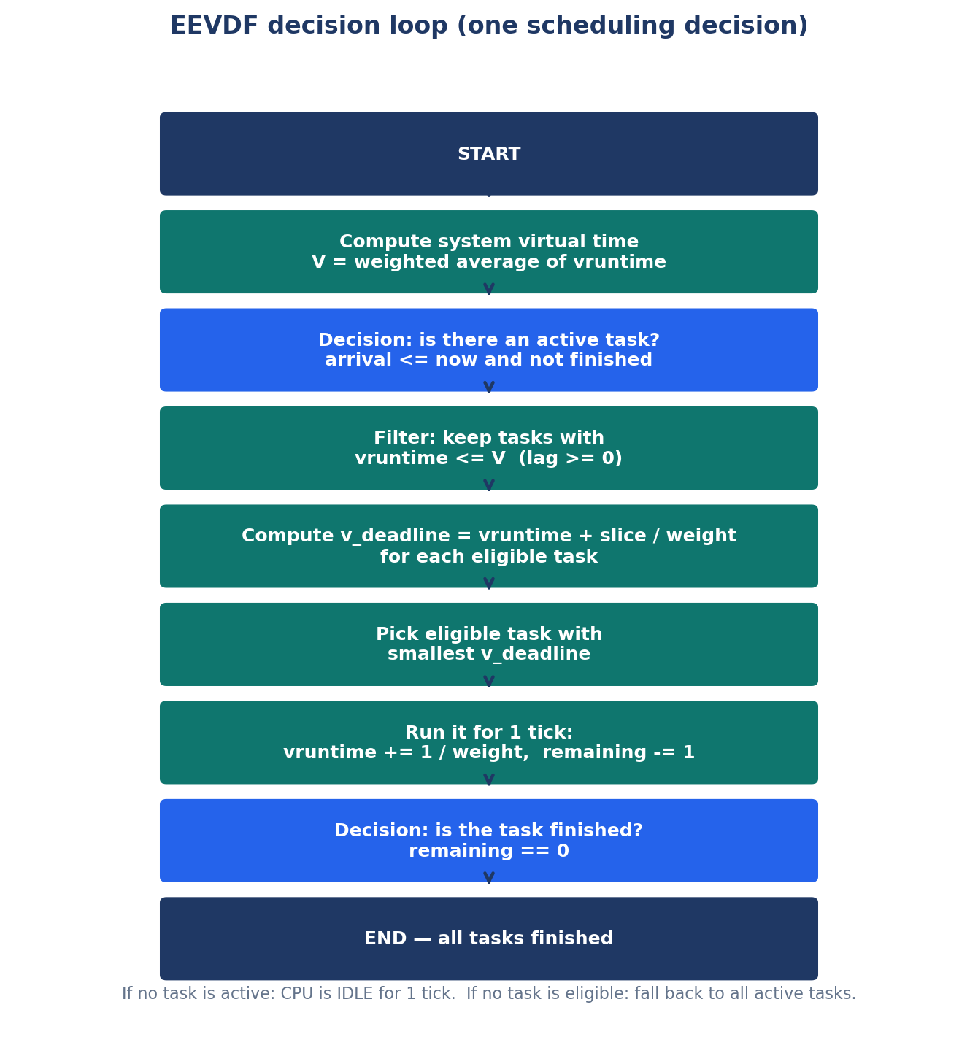
Figure 4. Flowchart of the EEVDF decision loop. One pass through the flowchart is one scheduling decision, and the loop repeats once per tick until all tasks are finished.
Two details in that procedure deserve emphasis, because students lose marks on them. The first is the tie-break. When two eligible tasks have the same virtual deadline, the code sorts by the pair (v_deadline, arrival), so the task that arrived earlier goes first. In Workload A at time 0, T1 and T2 both have virtual deadline 4.0 and both arrived at time 0, so the tie is broken by the order in the runqueue, and T1 runs first. That is deterministic, and it is the reason the trace is reproducible. The second detail is the fallback in step 5. A student who omits it has written a scheduler that can stall. A scheduler that stalls when there is work to do is not merely inefficient; it is incorrect. The code in Chapter 6 contains the fallback, and the flowchart contains it in the note at the bottom, and the reader should be able to point to it.

5.2 Formal pseudocode
The pseudocode below is the formal statement of the algorithm. It is written in the same notation as the code, so that the reader can compare the two line by line. The pseudocode is the specification, and the Python program in Chapter 6 is the implementation of the specification. Where they differ, the difference is a choice of the implementation, not a change of the algorithm, and the differences are listed in Chapter 6.
Pseudocode 1. The EEVDF decision loop. Compare it line by line with the Python code in Chapter 6.
function EEVDF(tasks):
current_time <- 0
timeline <- empty list
while not all tasks are complete:
active <- {t in tasks | t.arrival <= current_time
and t.remaining > 0}
if active is empty:
append IDLE to timeline
current_time <- current_time + 1
continue
total_weight <- sum(t.weight for t in active)
V <- sum(t.vruntime * t.weight for t in active)
/ total_weight
eligible <- {t in active | t.vruntime <= V}
if eligible is empty:
eligible <- active # fallback, never stall
for t in eligible:
t.v_deadline <- t.vruntime + t.slice / t.weight
sort eligible by (v_deadline, arrival), ascending
selected <- eligible[0]
if selected has never run:
selected.first_run <- current_time
append selected.tid to timeline
selected.remaining <- selected.remaining - 1
selected.vruntime <- selected.vruntime + 1 / selected.weight
current_time <- current_time + 1
if selected.remaining == 0:
selected.completed <- true
selected.finish <- current_time
return timeline and per-task metrics

Read the pseudocode once more, slowly, and notice what it does not contain. It does not contain a priority number. It does not contain a deadline in real time. It does not contain a test for whether a task is interactive or batch. It contains only vruntime, the average, the filter, and the deadline. That is the whole algorithm. A student who can write that pseudocode from memory, and can explain each line, understands EEVDF. A student who can only recite the name does not.
Worked check. Take two tasks, A with weight 1 and slice 4, and B with weight 2 and slice 1, both with vruntime 0 and both arrived. V is 0. Both are eligible. The virtual deadlines are 4 for A and 0.5 for B, so B runs first. After one tick, B has vruntime 0.5 and A still has 0. The new V is (1 * 0 + 2 * 0.5) / 3, which is about 0.33. Now A is eligible, because 0 <= 0.33, and B is not, because 0.5 > 0.33, so A runs next. That two-tick trace is EEVDF in miniature: the short, heavy request wins first, and then the filter stops it from winning again until the other task has caught up.

6. Implementation in Python
The implementation is the file EEVDF_Core_Algorithm/eevdf.py in the repository. It is 116 lines long, it uses only the Python standard library, and it needs no installation beyond Python 3. It is a pure model, which means it models the algorithm and nothing else: one CPU, integer ticks, no threads, no input and output, and no operating system. That purity is a strength for teaching, because there is nothing in the program except the algorithm, and it is a limitation for realism, because the real kernel is not pure, and the differences are listed at the end of this chapter and in Chapter 14. This chapter explains the program function by function, prints the complete code, shows how to run it, and shows the actual console output, so that every number in the rest of the report can be reproduced.

6.1 The Task class
The program begins with a class called Task. A class is a template for the data of one task, and each task in a workload is one object made from that template. The constructor, __init__, takes five arguments: tid, which is the name of the task, such as T1 (Batch); arrival, the arrival time; burst, the total work; weight, the weight; and time_slice, the requested slice. It stores the first four directly, and it stores the slice in the field called slice. It also sets remaining equal to burst, because a task that has just been created has done none of its work yet. Then it sets the three EEVDF parameters: vruntime to 0.0, v_deadline to 0.0, and lag to 0.0. Every task starts with a virtual runtime of zero, because it has received no service yet, and it starts with a virtual deadline of zero and a lag of zero because neither has been computed yet. Finally, it sets the statistics: completed to False, first_run to -1, meaning it has never run, and completion_time to 0. Those three fields are filled in by the scheduler as the task runs, and they are used at the end to compute the metrics. There is nothing else in the class. If you understand those fields, you understand the state of the whole system, because the whole state of the system is the list of Task objects and the clock.

6.2 The scheduler function, part by part
The scheduler is the function run_pure_eevdf(tasks). It takes a list of Task objects and it does not return a value; it prints the timeline and the metrics table to the console, which is the simplest possible interface for a teaching program. Its first lines set n to the number of tasks, current_time to 0, completed_count to 0, and timeline to an empty list. Then it prints a header. Then it enters the main loop, while completed_count < n, which is the loop that runs until every task is complete. Inside the loop, the first step is the one described in Chapter 5: active_tasks is the list of tasks whose arrival time is less than or equal to the current time and whose completed flag is False. If that list is empty, the program appends the string IDLE to the timeline, advances the clock by one, and goes round the loop again. That is the idle case, and Experiment D in Chapter 10 is built around it.
If there is at least one active task, the program computes total_weight as the sum of the weights of the active tasks, and avg_vruntime as the sum of vruntime multiplied by weight, divided by total_weight. Those two lines are the system virtual time V of Chapter 3. Then it builds the eligible list. For each active task it sets t.lag = (avg_vruntime - t.vruntime) * t.weight, and it keeps the task if t.vruntime <= avg_vruntime. That is the eligibility filter. If the eligible list is empty, it is replaced by the active list, which is the fallback of Chapter 5. Then, for each eligible task, it sets t.v_deadline = t.vruntime + (t.slice / t.weight). That is the virtual deadline. Then it sorts the eligible tasks by the key (v_deadline, arrival), so that the smallest deadline comes first and ties are broken by arrival, and it takes the first element as selected. If selected has never run, its first_run is set to the current time. Then the program appends the task's name to the timeline, decreases its remaining time by 1, increases its vruntime by 1.0 / selected.weight, and advances the clock by 1. If the remaining time is now zero, it marks the task complete, records the current time as its completion time, and increases completed_count by 1. Then the loop repeats.
After the loop finishes, the program prints the timeline as a single line with arrows between the task names, then it prints the metrics table. For each task it computes turnaround as completion_time minus arrival, waiting as turnaround minus burst, and response as first_run minus arrival. It adds those three numbers to running totals, prints one row per task, and then prints the three averages, each to two decimal places. The averages are computed by dividing the totals by n, the number of tasks. That is the whole program, apart from the main block, which builds the workload for the main experiment and calls the function. The main block is the last six lines of the file, and it is the workload of Chapter 7.

6.3 The complete code
The complete code is printed below, in three parts, exactly as it appears in the repository. Read it with Chapter 5 open beside it, and match each line of the code to a step of the pseudocode. There is no hidden code, no library, and no file that is not printed here.
Code 1. The Task class (lines 1-19 of eevdf.py).
class Task:
def __init__(self, tid, arrival, burst, weight, time_slice):
self.tid = tid
self.arrival = arrival
self.burst = burst
self.remaining = burst
self.weight = weight
self.slice = time_slice

# EEVDF Core Parameters
self.vruntime = 0.0
self.v_deadline = 0.0
self.lag = 0.0

# Statistics
self.completed = False
self.first_run = -1
self.completion_time = 0

Code 2. The scheduler loop: active tasks, system virtual time, eligibility, virtual deadline, and choice (lines 21-74 of eevdf.py).
def run_pure_eevdf(tasks):
n = len(tasks)
current_time = 0
completed_count = 0
timeline = []

print("=" * 80)
print("Running Pure EEVDF (Earliest Eligible Virtual Deadline First) Scheduler")
print("=" * 80)

while completed_count < n:
# 1. Filter active (ready) tasks at current clock tick
active_tasks = [t for t in tasks if t.arrival <= current_time and not t.completed]

if not active_tasks:
timeline.append("IDLE")
current_time += 1
continue

# 2. Compute system virtual time (weighted average of active vruntime)
total_weight = sum(t.weight for t in active_tasks)
avg_vruntime = sum(t.vruntime * t.weight for t in active_tasks) / total_weight

# 3. Determine Eligible Tasks (Lag >= 0 <==> vruntime <= avg_vruntime)
eligible_tasks = []
for t in active_tasks:
t.lag = (avg_vruntime - t.vruntime) * t.weight
if t.vruntime <= avg_vruntime:
eligible_tasks.append(t)

if not eligible_tasks:
eligible_tasks = active_tasks

# 4. Calculate Virtual Deadline for eligible tasks
# Formula: V_deadline = vruntime + (requested_slice / weight)
for t in eligible_tasks:
t.v_deadline = t.vruntime + (t.slice / t.weight)

# 5. Pick the eligible task with the earliest virtual deadline
eligible_tasks.sort(key=lambda x: (x.v_deadline, x.arrival))
selected = eligible_tasks[0]

if selected.first_run == -1:
selected.first_run = current_time

# 6. Execute task for 1 time unit
timeline.append(selected.tid)
selected.remaining -= 1
selected.vruntime += 1.0 / selected.weight
current_time += 1

Code 3. Completion, the metrics table, and the main workload (lines 75-116 of eevdf.py).
if selected.remaining == 0:
selected.completed = True
selected.completion_time = current_time
completed_count += 1

# Print Execution Timeline
print(f"\nExecution Timeline: {' -> '.join(timeline)}\n")

# Print Metrics Table
print("-" * 80)
print(
f"{'Task ID':<16} | {'Arrival':<7} | {'Burst':<5} | {'Weight':<6} | "
f"{'Slice':<5} | {'Finish':<6} | {'Turnaround':<10} | {'Waiting':<7} | {'Response':<8}"
)
print("-" * 80)

total_wait, total_turn, total_resp = 0, 0, 0
for t in tasks:
turnaround = t.completion_time - t.arrival
waiting = turnaround - t.burst
response = t.first_run - t.arrival

total_turn += turnaround
total_wait += waiting
total_resp += response

print(
f"{t.tid:<16} | {t.arrival:<7} | {t.burst:<5} | {t.weight:<6} | "
f"{t.slice:<5} | {t.completion_time:<6} | {turnaround:<10} | {waiting:<7} | {response:<8}"
)

print("-" * 80)
print(f"Average Waiting Time : {total_wait / n:.2f}")
print(f"Average Turnaround Time : {total_turn / n:.2f}")
print(f"Average Response Time : {total_resp / n:.2f}")
print("=" * 80)

if __name__ == "__main__":
workload = [
Task(tid="T1 (Batch)", arrival=0, burst=4, weight=1, time_slice=4),
Task(tid="T2 (Batch)", arrival=0, burst=4, weight=1, time_slice=4),
Task(tid="T3 (Interactive)", arrival=1, burst=2, weight=2, time_slice=1),
]
run_pure_eevdf(workload)

One small difference between the code as printed here and the file in the repository should be recorded honestly, so that no reader is confused. In the repository file, the header line printed at the start is preceded by a rocket emoji, and the print statement is print with an emoji character. In Code 2 above that emoji is omitted from the printed line, because the document builder renders the emoji inconsistently. The behaviour of the program is identical with or without it. Apart from that single character, the code above is the file, line for line. A reader who copies Code 1, Code 2, and Code 3 into a file called eevdf.py and runs it will obtain the output shown in the next section.

6.4 How to run it
Commands to obtain the repository and run the main experiment. Python 3 is required; no other package is required.
git clone https://github.com/komeil1385/EEVDF.git
cd EEVDF
python EEVDF_Core_Algorithm/eevdf.py

The program needs no installation, no virtual environment, and no third-party package. It uses only the Python standard library, and it runs on any computer with Python 3 installed. The command python may need to be python3 on some systems, and the program prints its output to the terminal, so no output file is created. The other programs in the repository are run in the same way, from their own folders, and the commands for them are given in their own README files and in Chapter 16. To run a different workload, for example one of the experiments in Chapters 8 to 10, change the workload list at the bottom of the file, or write a short script that imports Task and run_pure_eevdf from eevdf and calls the function with a new list. The experiments in this report were produced in exactly that way, and their workloads are printed in full in their chapters, so that any reader can reproduce them.

6.5 The actual console output
The output below is the actual output of the program on the main workload, copied from the terminal. It is the output that every number in Chapter 7 is taken from, and it is the output that corrects the old README file. The screenshot in the figure that follows it is the same output as it appeared in the editor, with the same numbers.
Console output 1. The actual run of eevdf.py on the main workload. Note T3 finishes at time 3, not 4, and the averages are 3.67, 7.00, and 1.00.
================================================================================
Running Pure EEVDF (Earliest Eligible Virtual Deadline First) Scheduler
================================================================================

Execution Timeline: T1 (Batch) -> T3 (Interactive) -> T3 (Interactive) -> T2 (Batch) -> T1 (Batch) -> T2 (Batch) -> T1 (Batch) -> T2 (Batch) -> T1 (Batch) -> T2 (Batch)

--------------------------------------------------------------------------------
Task ID | Arrival | Burst | Weight | Slice | Finish | Turnaround | Waiting | Response
--------------------------------------------------------------------------------
T1 (Batch) | 0 | 4 | 1 | 4 | 9 | 9 | 5 | 0
T2 (Batch) | 0 | 4 | 1 | 4 | 10 | 10 | 6 | 3
T3 (Interactive) | 1 | 2 | 2 | 1 | 3 | 2 | 0 | 0
--------------------------------------------------------------------------------
Average Waiting Time : 3.67
Average Turnaround Time : 7.00
Average Response Time : 1.00
================================================================================

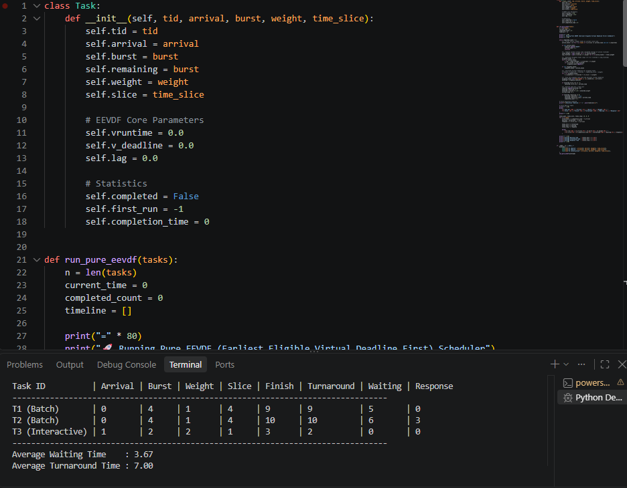
Figure 5. Screenshot of the repository result: the Task class in the editor and, in the terminal below it, the actual run of eevdf.py with T3 finishing at time 3 and an average waiting time of 3.67. This screenshot is the evidence for the correction in Chapter 7.

6.6 What the pure model leaves out
The pure model is deliberately small, and a student who mistakes it for the Linux kernel has misunderstood the report. The differences are listed here, and they are explained in full in Chapter 14. The model has a single CPU, and the kernel has many. The model moves in integer ticks, and the kernel measures time in nanoseconds. The model has no wakeup preemption, which is the kernel's rule that a task which wakes up can preempt the running task. The model has no nice-to-weight table, because weights are given directly. The model has no lag clamping and no sleeper placement, which are the kernel's rules for bounding how far behind a task that has slept can be, and for where a newly woken task starts. The model has no control groups, which are the kernel's way of giving a whole group of tasks a share. And the model uses floating-point arithmetic, while the kernel uses fixed-point arithmetic, because floating point is not allowed in the kernel. None of those differences changes the algorithm. They change the engineering around it. The algorithm is the filter and the deadline, and the filter and the deadline are the same in the model and in the kernel.

7. Main Experiment A: Two Batch Tasks and One Interactive Task
The main experiment is the workload built into the program, and it is the experiment the whole report is built around. It is deliberately small: two batch tasks and one interactive task. The batch tasks are heavy and patient. They arrive at time 0, they each need four ticks, they have weight 1, and they ask for a slice of 4. The interactive task is light and impatient. It arrives at time 1, it needs only two ticks, it has weight 2, and it asks for a slice of 1. The question the experiment answers is simple: when the interactive task arrives, does the scheduler notice it, and does it answer it quickly, without being unfair to the batch tasks? The answer, as the trace below shows, is yes, and the trace shows exactly how.
Table 3. Workload A: the main experiment. Two batch tasks and one interactive task.
Task | Type | Arrival | Burst | Weight | Slice
T1 | Batch | 0 | 4 | 1 | 4
T2 | Batch | 0 | 4 | 1 | 4
T3 | Interactive | 1 | 2 | 2 | 1

7.1 Tick-by-tick trace
The trace below is the heart of this chapter. Each row is one tick. The columns are the time at which the tick starts, the system virtual time V at that moment, the vruntime of each active task before the tick, the eligible set, the virtual deadline of each eligible task, the task chosen, and the vruntime of the chosen task after the tick. Every number in the table was computed by hand from the procedure of Chapter 5 and then checked against an instrumented run of the code, and the two agree exactly. Read the table row by row, and check one row yourself with a pencil before you trust the rest. That is the correct way to read a trace.
Table 4. Tick-by-tick trace of Workload A. At each tick, V is the weighted average of vruntime over the active tasks, the eligible set is the tasks with vruntime <= V, and the chosen task is the eligible task with the smallest virtual deadline.
t | V | vruntime before (T1, T2, T3) | Eligible | v_deadline (eligible) | Chosen | vruntime after chosen
0 | 0.00 | T1 0.0, T2 0.0 | T1, T2 | T1 4.0, T2 4.0 | T1 | T1 1.0
1 | 0.25 | T1 1.0, T2 0.0, T3 0.0 | T2, T3 | T2 4.0, T3 0.5 | T3 | T3 0.5
2 | 0.50 | T1 1.0, T2 0.0, T3 0.5 | T2, T3 | T2 4.0, T3 1.0 | T3 | T3 1.0
3 | 0.50 | T1 1.0, T2 0.0 | T2 | T2 4.0 | T2 | T2 1.0
4 | 1.00 | T1 1.0, T2 1.0 | T1, T2 | T1 5.0, T2 5.0 | T1 | T1 2.0
5 | 1.50 | T1 2.0, T2 1.0 | T2 | T2 5.0 | T2 | T2 2.0
6 | 2.00 | T1 2.0, T2 2.0 | T1, T2 | T1 6.0, T2 6.0 | T1 | T1 3.0
7 | 2.50 | T1 3.0, T2 2.0 | T2 | T2 6.0 | T2 | T2 3.0
8 | 3.00 | T1 3.0, T2 3.0 | T1, T2 | T1 7.0, T2 7.0 | T1 | T1 4.0
9 | 3.00 | T2 3.0 | T2 | T2 7.0 | T2 | T2 4.0

The trace rewards a slow reading, because it contains the whole algorithm in ten rows. At time 0, only T1 and T2 have arrived. Both have vruntime 0, so V is 0, both are eligible, and both have virtual deadline 4. The tie is broken by the runqueue order, and T1 runs. At time 1, T3 has arrived. T1 now has vruntime 1, while T2 and T3 have 0. The weighted average is (1 * 1 + 1 * 0 + 2 * 0) / 4, which is 0.25. T1 is ahead of the average, with a lag of -0.75, and it is not eligible. T2 and T3 are eligible, and their virtual deadlines are 4.0 and 0.5. T3 wins by a large margin, because it asks for a slice of 1 and has weight 2. At time 2, T3 has vruntime 0.5, T1 still has 1.0, and T2 still has 0. The average is now 0.5. T1 is still ahead, with a lag of -0.5, and T3 is exactly on the average, with a lag of 0, so it is eligible, and its virtual deadline is 1.0, which is still far earlier than T2's 4.0. T3 runs again and finishes. That is the whole story of the interactive task: it arrived at time 1, it ran at times 1 and 2, and it finished at time 3, after waiting for no time at all.
The rest of the trace is the two batch tasks taking turns. At time 3, only T1 and T2 are left. T1 has vruntime 1.0, T2 has 0, and V is 0.5, so only T2 is eligible, and it runs. At time 4, both have vruntime 1.0, V is 1.0, both are eligible, both have virtual deadline 5.0, and T1 runs on the tie. At time 5, T1 is ahead again, so T2 runs. The pattern repeats: the two tasks alternate, one tick each, until they finish. That alternation is not Round Robin. Round Robin would alternate because it is told to. EEVDF alternates because the eligibility filter forbids the task that has just run from running again until the other task has caught up. The filter is doing the work, and the deadline is doing the tie-breaking. At time 9, only T2 is left, and it runs its last tick and finishes at time 10. The timeline is T1, T3, T3, T2, T1, T2, T1, T2, T1, T2, and the finish times are 9, 10, and 3.
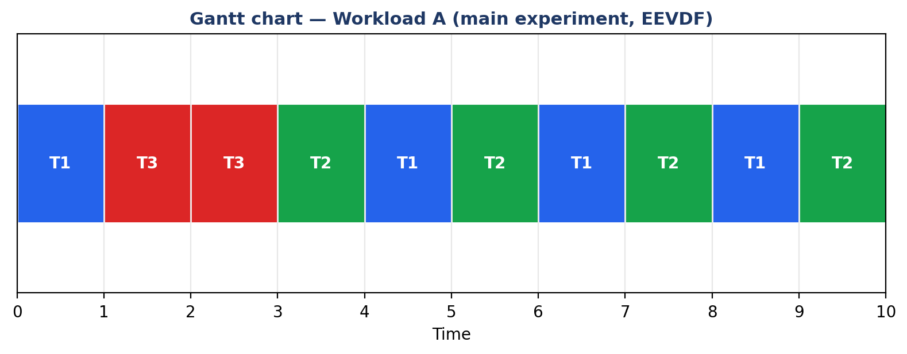
Figure 6. Gantt chart of Workload A. T3, the interactive task, runs in the two ticks immediately after its arrival at time 1, and the two batch tasks then alternate until they finish.
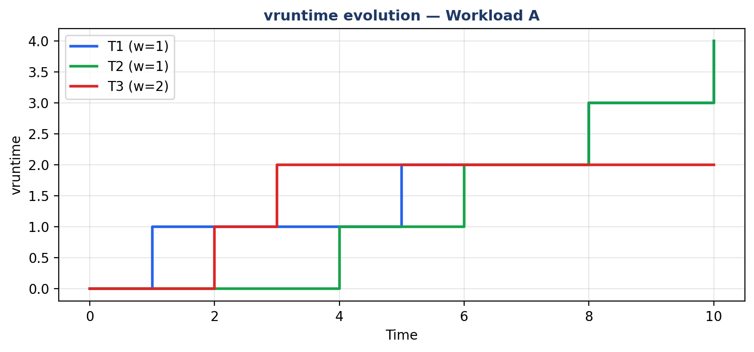
Figure 7. Evolution of vruntime in Workload A. T3 rises quickly because its weight is 2, so each tick adds only 0.5, but it finishes after two ticks. T1 and T2 rise by 1.0 per tick they run, and they end together at 4.0.

7.2 Metrics
The metrics are computed from the finish times and the first-run times, by the definitions of Chapter 3. T1 arrived at 0 and finished at 9, so its turnaround is 9, its waiting time is 9 minus its burst of 4, which is 5, and its response time is 0, because it ran at time 0. T2 arrived at 0 and finished at 10, so its turnaround is 10, its waiting time is 6, and its response time is 3, because it first ran at time 3. T3 arrived at 1 and finished at 3, so its turnaround is 2, its waiting time is 0, and its response time is 0, because it first ran at time 1, the moment it arrived. The averages are the sums divided by 3. The sum of the waiting times is 5 + 6 + 0 = 11, and 11 / 3 is 3.67. The sum of the turnaround times is 9 + 10 + 2 = 21, and 21 / 3 is 7.00. The sum of the response times is 0 + 3 + 0 = 3, and 3 / 3 is 1.00. Every number in the table below can be checked from the trace in the previous section, and the reader should check at least one row before moving on.
Table 5. Metrics of Workload A, from the actual run of eevdf.py.
Task | Arrival | Burst | Finish | Turnaround | Waiting | Response
T1 (Batch) | 0 | 4 | 9 | 9 | 5 | 0
T2 (Batch) | 0 | 4 | 10 | 10 | 6 | 3
T3 (Interactive) | 1 | 2 | 3 | 2 | 0 | 0
Average | - | - | - | 7.00 | 3.67 | 1.00

7.3 Interpretation
Three things should be noticed about these numbers. First, the interactive task is answered immediately. Its response time is 0 and its waiting time is 0. It arrived at time 1 and it ran at time 1. That is the latency goal, achieved. Second, the batch tasks are not starved. They both finish, they finish close together, at times 9 and 10, and their waiting times, 5 and 6, are the price of sharing the processor with each other and with the interactive task. No batch task waits because the interactive task took more than its share; the interactive task took only two ticks, which is exactly its burst, and it took them early because its virtual deadline was early, not because it was given a privilege. Third, the average response time of 1.00 is pulled up by T2, which waited until time 3 for its first run. That is the cost of the tie at time 0 and of the interactive task's arrival at time 1. T2 is the task that pays for the latency of T3, and it pays three ticks. That is a fair price, and it is small, and it is the reason the averages are what they are. A scheduler that gave T3 a response of 0 and T2 a response of 10 would be a bad scheduler, even if its average looked good, because the distribution would be unfair. EEVDF gives T3 a response of 0 and T2 a response of 3, and that distribution is fair.

7.4 Correction of the old README
The old README file in the repository gave different numbers for this workload, and this report corrects them, because a report that repeats a known error is worse than a report that admits one. The old README claimed that T3 finished at time 4, that its turnaround was 3 and its waiting time was 1, and that the averages were waiting 4.00, turnaround 7.33, and response 0.33. Those numbers are incorrect. The actual run, shown in Chapter 6 and in the screenshot there, gives T3 a finish of 3, a turnaround of 2, and a waiting time of 0, and averages of 3.67, 7.00, and 1.00. The timeline in the old README also differed: it claimed T1, T3, T2, T3, T1, T2, T1, T2, T1, T2, while the actual run gives T1, T3, T3, T2, T1, T2, T1, T2, T1, T2. The difference is in the second and third ticks: in the actual run, T3 runs twice in a row, at times 1 and 2, because at time 2 it is still eligible and still has the earliest virtual deadline. The old README had T2 running at time 2, which would require T3 to be ineligible or to have a later deadline at that moment, and neither is true. The error probably came from writing the timeline by hand instead of copying it from the program output. The lesson is a general one, and it applies to every experiment in this report: copy the numbers from the program, do not write them from memory, and check them against the trace.
How to check this yourself. Run python EEVDF_Core_Algorithm/eevdf.py, copy the timeline and the table, and compare them with Table 7.2 above. Then change the workload at the bottom of the file, for example by giving T3 a weight of 1 instead of 2, run it again, and watch the timeline change. That single experiment teaches more about EEVDF than a page of theory.

8. Experiment B: Equal Weights
Experiment B removes weight from the picture, so that the reader can see what EEVDF does when every task is equal. Three tasks, T1, T2, and T3, all arrive at time 0, all have a burst of 3, all have weight 1, and all ask for a slice of 2. If weight is the only thing that distinguishes tasks, and the weights are equal, then the scheduler should treat the tasks equally, and the experiment tests whether it does. It is the control experiment for Experiment C, in which the weights are unequal, and the two experiments should be read together.
Table 6. Workload B: three identical tasks. The only difference between them is their name.
Task | Arrival | Burst | Weight | Slice
T1 | 0 | 3 | 1 | 2
T2 | 0 | 3 | 1 | 2
T3 | 0 | 3 | 1 | 2

The timeline is T1, T2, T3, T1, T2, T3, T1, T2, T3. It is a perfect rotation, one tick each, repeated three times. The trace explains why. At time 0, all three have vruntime 0, V is 0, all are eligible, and all have virtual deadline 2. T1 runs on the tie. At time 1, T1 has vruntime 1, the others have 0, and V is 0.33. T1 is ahead and is not eligible. T2 and T3 are eligible, both with deadline 2, and T2 runs. At time 2, T1 and T2 have vruntime 1, T3 has 0, and V is 0.67. Only T3 is eligible, and it runs. At time 3, all three have vruntime 1, V is 1, all are eligible, and all have deadline 3. T1 runs, and the cycle repeats. The pattern is exact, because the tasks are identical, and the scheduler has no reason to prefer one over another. The finish times are 7, 8, and 9, in the order the tasks first ran, and the metrics are waiting 4, 5, and 6, turnaround 7, 8, and 9, and response 0, 1, and 2. The averages are waiting 5.00, turnaround 8.00, and response 1.00.
Table 7. Metrics of Experiment B, from the actual run.
Task | Arrival | Burst | Finish | Turnaround | Waiting | Response
T1 | 0 | 3 | 7 | 7 | 4 | 0
T2 | 0 | 3 | 8 | 8 | 5 | 1
T3 | 0 | 3 | 9 | 9 | 6 | 2
Average | - | - | - | 8.00 | 5.00 | 1.00

The interpretation is short, because the experiment is simple. When the weights are equal, EEVDF behaves like a fair rotation, and each task receives one tick in turn. The waiting times increase by one for each task in the order of first run, which is the unavoidable cost of sharing one processor among three tasks that all want it at once. No task is favoured, and no task is starved. The average waiting time of 5.00 is larger than the 3.67 of Workload A, but that is not a failure. Workload A has a total burst of 10 ticks, while Experiment B has a total burst of 9 ticks spread over three tasks that all arrive at once, and the waiting time is higher because the contention is higher at the start. Comparing averages across different workloads is meaningless unless the workloads are the same, and the reader should not compare 5.00 with 3.67 as if one were better than the other. The value of Experiment B is not its average. It is the proof that, when there is nothing to distinguish the tasks, EEVDF distinguishes nothing.

9. Experiment C: Unequal Weights, 2:1:1
Experiment C puts weight back into the picture, and it does so in the simplest way that shows an effect. Three tasks, all with a burst of 4, all arriving at time 0. T1 has weight 2 and asks for a slice of 2. T2 and T3 have weight 1 and ask for a slice of 4. The total burst is 12, and the weights sum to 4, so the ideal shares are one-half for T1 and one-quarter each for T2 and T3. Over 12 ticks, T1 should receive about 6 ticks, and T2 and T3 about 3 each, but they each need 4, so the shares cannot all be satisfied at once, and the question is who finishes first and by how much. The answer is that T1 finishes first, at time 7, while T2 finishes at 11 and T3 at 12, and the trace shows why.
Table 8. Workload C: the same burst for all tasks, weights 2, 1, and 1.
Task | Arrival | Burst | Weight | Slice
T1 | 0 | 4 | 2 | 2
T2 | 0 | 4 | 1 | 4
T3 | 0 | 4 | 1 | 4

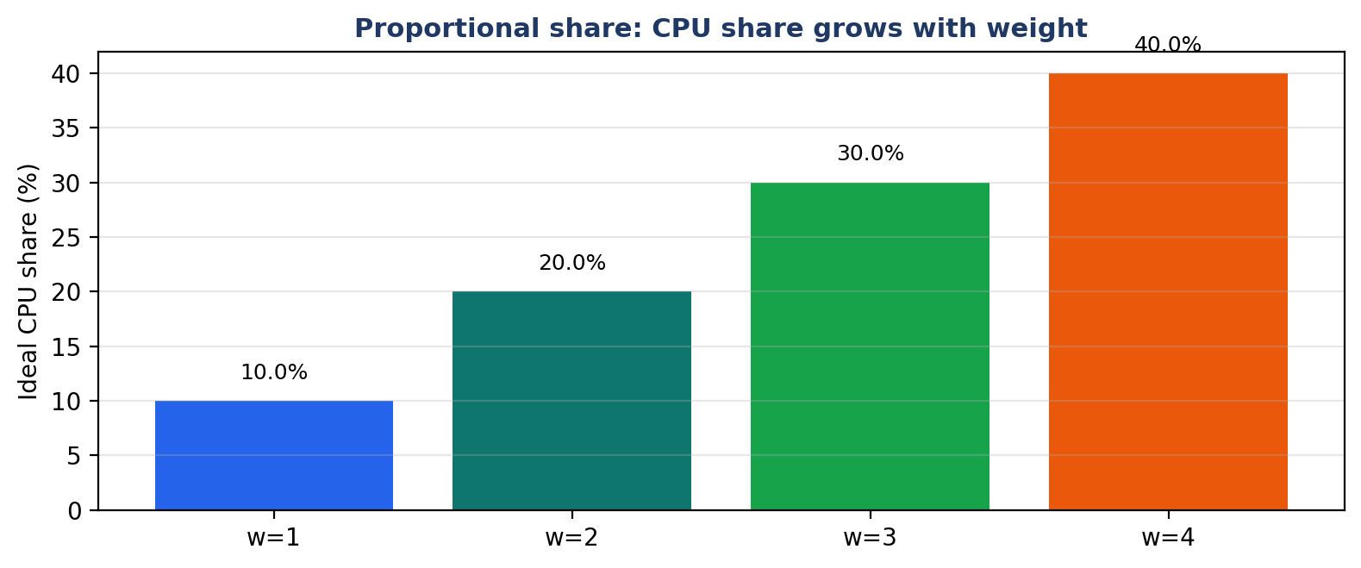
Figure 8. Proportional share: a task's ideal share of the processor grows with its weight. With weights 1, 2, 3, and 4, the shares are 10, 20, 30, and 40 percent.
The timeline is T1, T2, T1, T3, T1, T2, T1, T3, T2, T3, T2, T3. The trace begins at time 0 with all three tasks at vruntime 0 and V at 0. All are eligible. Their virtual deadlines are 1.0 for T1, because 0 + 2/2 = 1, and 4.0 for T2 and T3, because 0 + 4/1 = 4. T1 wins by a large margin, and it runs. At time 1, T1 has vruntime 0.5, the others have 0, and V is 0.25. T1 is ahead and is not eligible. T2 and T3 are eligible with deadline 4.0, and T2 runs. At time 2, T1 has 0.5, T2 has 1.0, and T3 has 0, and V is 0.5. T1 and T3 are eligible. T1's deadline is 1.5, T3's is 4.0, so T1 runs again. At time 3, all three have vruntime 1.0 except T3, which has 0, and V is 0.75. Only T3 is eligible, and it runs. The pattern continues: T1 runs whenever it is eligible, because its deadline is always the earliest, and T2 and T3 take turns when T1 is ahead. T1 finishes at time 7, after running at times 0, 2, 4, and 6. T2 and T3 then share the remaining time, and finish at 11 and 12.
Table 9. Metrics of Experiment C, from the actual run.
Task | Arrival | Burst | Finish | Turnaround | Waiting | Response
T1 (w=2) | 0 | 4 | 7 | 7 | 3 | 0
T2 (w=1) | 0 | 4 | 11 | 11 | 7 | 1
T3 (w=1) | 0 | 4 | 12 | 12 | 8 | 3
Average | - | - | - | 10.00 | 6.00 | 1.33

The interpretation is the point of the experiment. T1 has the same burst as the other two tasks, 4 ticks, and it finishes first, at time 7, while the others finish at 11 and 12. It finishes first because its weight is 2, and its weight does two things for it. First, it makes its vruntime grow slowly, by 0.5 per tick instead of 1.0, so it stays eligible more often. Second, it makes its virtual deadline early, because its slice of 2 is divided by 2, giving a deadline only 1.0 above its vruntime, while the other tasks' deadlines are 4.0 above theirs. Both effects point in the same direction, and they are the same effect seen from two sides: the weight corrects the measurement of service, and it also corrects the price of the next request. The waiting times tell the same story from the other side. T1 waits for 3 ticks, T2 for 7, and T3 for 8. The heavy task waits less, because it is owed more. That is fairness, not favouritism. If the weights were reversed, and T3 had weight 2, then T3 would finish first. The experiment proves that the scheduler listens to the weight, and it proves it with a finish time that anyone can read off the table.
A student should also notice what does not happen in this experiment. T1 does not monopolise the processor. It runs four times in the first seven ticks, but it does not run four times in a row, because after each run it is ahead and the filter stops it. The other tasks run in between, and they finish, even though they are lighter. A scheduler that gave the heavy task everything would finish T1 at time 4 and leave the others waiting until time 12, and its average waiting time would be worse. EEVDF does not do that, because the filter forbids it. Weight is a share, not a priority, and the difference between a share and a priority is the difference between EEVDF and a priority scheduler. Chapter 13 makes that comparison explicit.

10. Experiments D and E: Late Arrival and the Interactive Task
Experiments D and E are smaller than A, B, and C, but they each isolate one effect that the larger experiments mix together. Experiment D isolates the idle case: what happens when no task is ready. Experiment E isolates the interactive case: what happens when a short, heavy task arrives in the middle of a long batch task. Both are worth doing, because both are cases that a student will meet in an examination, and both have answers that are easy to get wrong if the procedure is not followed step by step.

10.1 Experiment D: late arrival and idle time
The workload is two tasks. T1 arrives at time 0, needs 2 ticks, has weight 1, and asks for a slice of 2. T2 arrives at time 5, needs 2 ticks, has weight 1, and asks for a slice of 1. There is a gap between time 2, when T1 finishes, and time 5, when T2 arrives, and in that gap there is no work to do. The timeline is T1, T1, IDLE, IDLE, IDLE, T2, T2. The finish times are 2 and 7. The turnaround times are 2 and 2, the waiting times are 0 and 0, and the response times are 0 and 0. The averages are waiting 0.00, turnaround 2.00, and response 0.00.
Table 10. Workload and metrics of Experiment D. The CPU is idle at times 2, 3, and 4.
Task | Arrival | Burst | Weight | Slice | Finish | Turnaround | Waiting | Response
T1 | 0 | 2 | 1 | 2 | 2 | 2 | 0 | 0
T2 | 5 | 2 | 1 | 1 | 7 | 2 | 0 | 0
Average | - | - | - | - | - | 2.00 | 0.00 | 0.00

The interpretation is that idle time is not a failure of the scheduler. When no task has arrived, the scheduler cannot invent work, and the correct behaviour is to idle. The code does that by appending IDLE to the timeline and advancing the clock. A student who traces this workload and forgets the idle ticks will get the finish time of T2 wrong: T2 arrives at 5, runs at 5 and 6, and finishes at 7, not at 2. The idle ticks are part of the schedule, and they are part of the timeline. The metrics are also instructive. Both tasks have a waiting time of zero, because neither ever waits for the processor when it is ready. T1 runs immediately on arrival, and T2 runs immediately on arrival, because the processor is idle when each arrives. The average waiting time of zero does not mean the scheduler is perfect. It means there was no contention. Averages without contention are easy, and the reader should not compare them with the averages of the other experiments, where there was contention.

10.2 Experiment E: the interactive task arrives late
The workload is two tasks. T1 is a batch task. It arrives at time 0, needs 6 ticks, has weight 1, and asks for a slice of 6. T2 is an interactive task. It arrives at time 2, needs 2 ticks, has weight 2, and asks for a slice of 1. The timeline is T1, T1, T2, T2, T1, T1, T1, T1. The finish times are 8 for T1 and 4 for T2. The turnaround times are 8 and 2, the waiting times are 2 and 0, and the response times are 0 and 0. The averages are waiting 1.00, turnaround 5.00, and response 0.00.
Table 11. Workload and metrics of Experiment E. T2 is answered immediately on arrival.
Task | Type | Arrival | Burst | Weight | Slice | Finish | Turnaround | Waiting | Response
T1 | Batch | 0 | 6 | 1 | 6 | 8 | 8 | 2 | 0
T2 | Interactive | 2 | 2 | 2 | 1 | 4 | 2 | 0 | 0
Average | - | - | - | - | - | - | 5.00 | 1.00 | 0.00

The trace is short enough to follow in words. At time 0, only T1 is active, so it runs. At time 1, only T1 is active, so it runs again. Its vruntime is now 2.0. At time 2, T2 arrives with vruntime 0. The system virtual time is (1 * 2.0 + 2 * 0.0) / 3, which is about 0.67. T1 is ahead, with vruntime 2.0, and T2 is behind, with vruntime 0. T2 is eligible, T1 is not, and T2's virtual deadline is 0.5, so T2 runs. At time 3, T2 has vruntime 0.5, T1 still has 2.0, and V is about 1.0. T2 is still eligible, and T1 is still ahead, so T2 runs again and finishes at time 4. Then T1 runs for its remaining four ticks and finishes at time 8. The interactive task waited for no time at all. It arrived at time 2, it ran at time 2, and it finished at time 4. Its response time is 0 and its waiting time is 0. The batch task waited for two ticks, at times 2 and 3, while the interactive task ran, and its waiting time is 2. That is the price of latency, and it is two ticks. The experiment proves, on the smallest possible workload, that EEVDF answers an interactive task immediately, even when a batch task is already running, and it proves it without any special case for interactive tasks. The scheduler did not know that T2 was interactive. It only saw a task with a short slice and a large weight, and it gave that task an early virtual deadline.
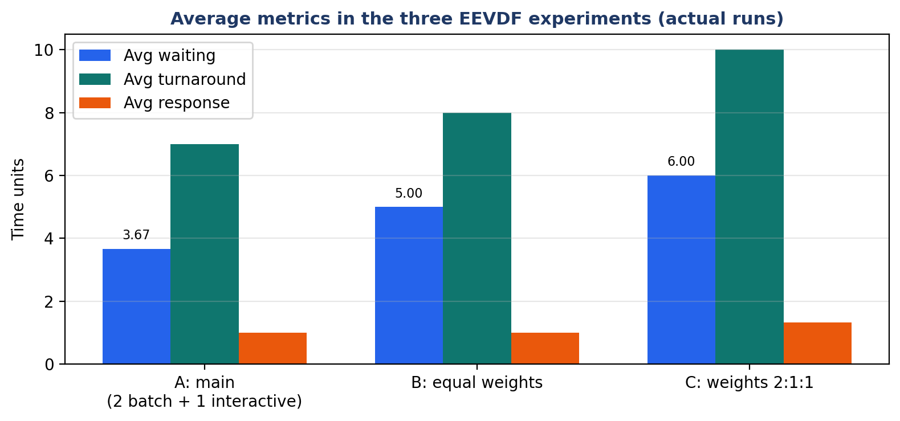
Figure 9. Average metrics in Experiments A, B, and C, from the actual runs. The averages cannot be compared across workloads, because the workloads differ; they are shown together so that the pattern within each experiment can be seen.
Read together, the five experiments tell a coherent story. Experiment A shows the full picture on a mixed workload. Experiment B shows that equal tasks are treated equally. Experiment C shows that weight changes the outcome in the direction of the weight. Experiment D shows that idle time is handled correctly. Experiment E shows that an interactive task is answered immediately. No single experiment proves the algorithm, and the report does not claim that any of them does. Together, they illustrate the theory of Chapter 4 on workloads small enough to trace by hand, and that is what experiments in a teaching report are for.

11. The Virtual Deadline and the Slice
The virtual deadline is the part of EEVDF that controls latency, and the slice is the input that controls the virtual deadline. This chapter studies that relationship in isolation, because it is the relationship that most students misunderstand. The formula is v_deadline = vruntime + r / w. For a fixed vruntime and a fixed weight, the deadline grows in direct proportion to the slice. Double the slice, and the distance from vruntime to the deadline doubles. Halve the slice, and the distance halves. For a fixed vruntime and a fixed slice, the deadline shrinks as the weight grows. Double the weight, and the distance halves. The two effects are independent, and they multiply. A task that asks for a short slice and has a large weight has a deadline very close to its vruntime, and it will be chosen before almost any other task. A task that asks for a long slice and has a small weight has a deadline far from its vruntime, and it will be chosen last. The scheduler does not need to be told which task is important. The deadline tells it.
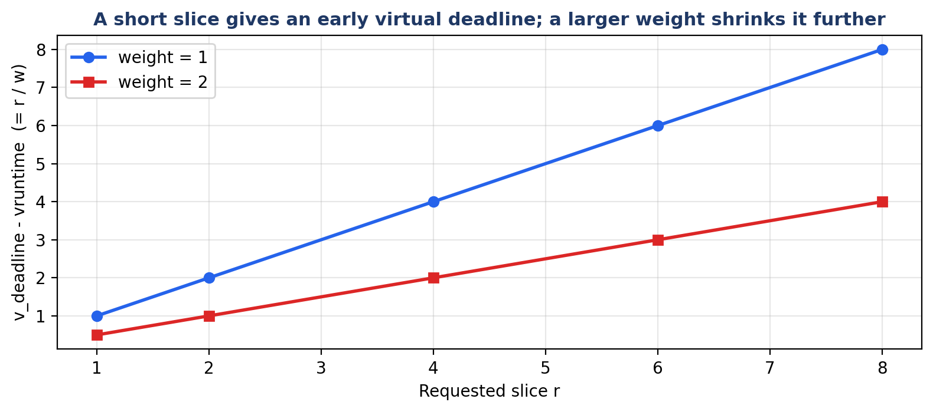
Figure 10. A short slice gives an early virtual deadline, and a larger weight shrinks the distance further. The vertical axis is v_deadline minus vruntime, which is r / w.

11.1 Sensitivity table
The table below computes r / w, which is the distance from vruntime to the virtual deadline, for slices of 1, 2, 4, 6, and 8, and for weights of 1 and 2. The numbers are exact, and they should be read as a map of the scheduler's preferences. A distance of 0.5 means the task's deadline is half a unit above its vruntime. A distance of 8.0 means the deadline is eight units above. The scheduler always chooses the smallest distance among the eligible tasks, after adding the vruntime, so the table is a direct guide to who wins.
Table 12. Sensitivity of the virtual deadline to the slice and the weight. The distance is r / w.
Slice r | r / w, weight 1 | r / w, weight 2 | Reading
1 | 1.0 | 0.5 | The shortest request; wins almost always
2 | 2.0 | 1.0 | A short request; wins against long slices
4 | 4.0 | 2.0 | A medium request; the batch slice of Workload A
6 | 6.0 | 3.0 | A long request; wins only when nothing shorter is eligible
8 | 8.0 | 4.0 | The longest request; waits the longest

Work through the table with two tasks in mind. Task A has weight 1 and asks for a slice of 8. Its distance is 8.0. Task B has weight 1 and asks for a slice of 1. Its distance is 1.0. If both have the same vruntime and both are eligible, B wins, because 1.0 is smaller than 8.0. Now give A a weight of 2. Its distance becomes 4.0. B still wins, because 1.0 is smaller than 4.0. Now give B a weight of 1 and a slice of 4, so its distance is 4.0, and give A a weight of 2 and a slice of 8, so its distance is also 4.0. Now they tie, and the tie is broken by arrival time. The table shows that a weight can compensate for a long slice, but only up to a point. A weight of 2 halves the distance, but it does not make a slice of 8 as cheap as a slice of 1. The slice is the stronger lever for latency, and the weight is the stronger lever for share, and the two should not be confused. A student who wants low latency should ask for a short slice. A student who wants a large share should ask for a large weight. A task that wants both should ask for a short slice and carry a large weight, and it will receive both, because the formula gives it both.

11.2 Why interactive tasks win
An interactive task wins in EEVDF for a reason that has nothing to do with favouritism and everything to do with arithmetic. An interactive task, by definition, does a small amount of work and then waits for the user. It therefore asks for a short slice, because it does not need a long one, and it arrives with a small vruntime, because it has not run much. Both facts make its virtual deadline early. Its vruntime is small, so the deadline starts from a small number, and its slice is small, so the deadline does not move far from that number. A batch task, by contrast, asks for a long slice, because it has a lot of work to do, and it has a large vruntime, because it has already run a lot. Both facts make its virtual deadline late. The scheduler does not need a flag that says interactive. It only needs the two numbers, and the numbers carry the information. That is an elegant design, and it is also a robust one, because it cannot be fooled by a task that claims to be interactive but asks for a long slice. Such a task will receive a late deadline, and it will wait, as it should. The system rewards behaviour, not labels.
The same reasoning explains why EEVDF is better than CFS for latency, and why the kernel changed. CFS chooses the task with the smallest vruntime, and vruntime alone does not contain the slice. Two tasks with the same vruntime are equal in CFS, even if one of them wants a short slice and the other wants a long one. EEVDF adds the slice to the decision, through the deadline, and the task that wants a short slice wins. The difference is small in the formula and large in the behaviour, and it is the reason the kernel developers made the change. A reader who understands this chapter understands the reason for the change, and a reader who does not understand it will think the change was a matter of fashion. It was not. It was a matter of one term in one formula.
A common error. Students sometimes say that a larger slice gives an earlier deadline, because a larger slice means the task wants more and should be given it sooner. The formula says the opposite, and the intuition is backwards. A larger slice means the task is asking for more work in one go, and the scheduler therefore places its finish further in the future. The task that asks for less finishes sooner, and it is chosen first because its finish is sooner. If you remember nothing else from this chapter, remember that short means early.

12. Lag and Eligibility in Depth
Chapter 3 defined lag and eligibility. This chapter studies them in depth, because they are the part of the algorithm that students find hardest to trace, and because they are the part that guarantees fairness. The chapter works through four cases, each with numbers, and then explains the fallback rule, and then explains what happens to a task that is ineligible, tick by tick, until it becomes eligible again.

12.1 Four worked cases
Case 1: a task that is behind. V is 1.0. Task A has weight 1 and vruntime 0.5. Its lag is (1.0 - 0.5) * 1 = 0.5. It is positive, so A is eligible. It is owed half a unit of service, and the scheduler is allowed to give it that service. Case 2: a task that is ahead. V is 1.0. Task B has weight 1 and vruntime 1.5. Its lag is (1.0 - 1.5) * 1 = -0.5. It is negative, so B is not eligible. It has received half a unit more than its fair share, and it must wait until V catches up with it. Case 3: a task that is exactly on schedule. V is 1.0. Task C has weight 2 and vruntime 1.0. Its lag is (1.0 - 1.0) * 2 = 0. It is zero, and zero is greater than or equal to zero, so C is eligible. The equality case is included, and it must be, or the system could stall when all tasks are exactly on schedule. Case 4: a heavy task that is slightly ahead. V is 1.0. Task D has weight 4 and vruntime 1.25. Its lag is (1.0 - 1.25) * 4 = -1.0. It is ahead by a full unit of service, even though its vruntime is only 0.25 above the average, because its weight multiplies the difference. Weight amplifies lag, in both directions. A heavy task that is behind by a small amount of vruntime is behind by a large amount of service, and a heavy task that is ahead by a small amount of vruntime is ahead by a large amount of service. That is correct, because a heavy task consumes service faster, and the lag must be measured in service, not in vruntime.
Table 13. Four cases of lag and eligibility. The rule is lag >= 0, equivalently vruntime <= V.
Case | V | Task | Weight | vruntime | Lag | Eligible?
1: behind | 1.0 | A | 1 | 0.5 | 0.5 | Yes
2: ahead | 1.0 | B | 1 | 1.5 | -0.5 | No
3: on schedule | 1.0 | C | 2 | 1.0 | 0.0 | Yes
4: heavy and ahead | 1.0 | D | 4 | 1.25 | -1.0 | No

12.2 What happens to an ineligible task?
An ineligible task is not punished, and it is not removed from the runqueue. It simply waits for one tick, and at the next tick the scheduler recomputes V and reconsiders it. While it waits, the other tasks run, and their vruntime increases, and V increases with them, because V is the average of vruntime. As V rises, the gap between V and the ineligible task's vruntime shrinks, and eventually V reaches the task's vruntime, its lag reaches zero, and it becomes eligible again. The mechanism is self-correcting, and it needs no timer and no explicit wake-up. The waiting task is woken by the arithmetic itself. Workload A shows this happening to T1. At time 1, T1 has vruntime 1.0 and V is 0.25, so T1 is ineligible, and it waits while T3 runs. At time 2, T1 still has vruntime 1.0, but V has risen to 0.5, so the gap has shrunk from 0.75 to 0.5. At time 3, T1 still has 1.0, V is 0.5, and T1 is still ineligible, so T2 runs. At time 4, T2 has vruntime 1.0, T1 has 1.0, and V is 1.0, so T1 is eligible again, and it runs. T1 waited for three ticks, from time 1 to time 4, and it waited because it was ahead, and it became eligible again because the system caught up with it. That is the whole story of ineligibility, and it is a story about waiting, not about punishment.

12.3 The fallback rule
The code contains a rule that the trace never needs, and the student should understand why it is there. If the eligible list is empty, the code replaces it with the active list. That is, if no task passes the filter, the scheduler runs the active tasks as if there were no filter. When can that happen? It can happen only if every active task has vruntime strictly greater than V, which is impossible if V is the weighted average of those same vruntimes, because at least one task must be less than or equal to the average. In exact arithmetic, the eligible set is never empty. In floating-point arithmetic, rounding can, in principle, make a task that should be exactly equal appear slightly greater, and the fallback protects against that case. It also protects against any future change to the definition of eligibility that might leave the set empty. The rule is therefore a safety net, not a part of the algorithm's logic, and a student who removes it has not changed the behaviour of the program on any workload in this report, but has made the program less robust. The flowchart in Chapter 5 records the fallback in its note, and the pseudocode records it in the line that says if eligible is empty, eligible becomes active. The reader should be able to point to that line in both places.

12.4 Eligibility is not priority
Eligibility is sometimes confused with priority, and the confusion is worth correcting explicitly. A priority is a fixed number attached to a task, and a high-priority task runs before a low-priority task, regardless of how much it has already run. Eligibility is not fixed. It changes at every tick, because V changes and vruntime changes, and a task that is eligible now may be ineligible at the next tick, and a task that is ineligible now may be eligible at the next tick. A priority scheduler can starve a low-priority task forever, if high-priority tasks keep arriving. EEVDF cannot starve a task forever, because a task that waits sees V rise towards it, and eventually it becomes eligible, and when it becomes eligible it has a small vruntime and therefore an early deadline, so it is chosen soon. Starvation is prevented by the same mechanism that enforces fairness, and that is the point of the design. If you remember one sentence from this chapter, remember that eligibility is a moving test, not a fixed rank.

13. Comparison with Other Schedulers
No scheduler should be judged in isolation, and EEVDF is no exception. This chapter compares it with six other schedulers: Round Robin, Rate Monotonic, Earliest Deadline First, the Completely Fair Scheduler, Lottery scheduling and Stride scheduling, which are treated together because they are the two classic proportional-share schedulers that the 1995 paper compares itself with. The comparison is made in two parts. The first part is a master table that compares the algorithms on twelve criteria, in theory. The second part is an actual experiment, in which RM, EDF, and EEVDF are run on the same workload, with the same code, and the measured numbers are reported. The two parts must be read together, because the theory says what each algorithm is designed to do, and the experiment says what they actually did on one small workload, and the two do not always agree.

13.1 The master comparison table
Table 14. Master comparison table: EEVDF against six other schedulers on twelve criteria.
Criterion | Round Robin | Rate Monotonic (RM) | Earliest Deadline First (EDF) | Completely Fair Scheduler (CFS) | Lottery / Stride | EEVDF
Priority policy | None; equal rotation | Static; shorter period first | Dynamic; earliest absolute deadline | Dynamic; smallest vruntime | Random tickets / deterministic stride | Dynamic; earliest virtual deadline among eligible
Utilisation bound | 100% (no deadlines) | About 69.3% (Liu and Layland) | 100% | 100% (no deadlines) | 100% (no deadlines) | 100% with fairness guarantee
Overload behaviour | All tasks slow equally | Unpredictable deadline misses | Domino effect; all tasks can fail | Graceful; shares shrink | Graceful; shares shrink | Graceful degradation; lag bounded by one quantum
Starvation protection | Yes, by rotation | No; low priority can starve | No; a task can wait indefinitely | Yes, via vruntime | Yes, in expectation (Lottery) or exactly (Stride) | Yes, via eligibility filtering
Interactive latency | Fair; depends on quantum | High for low-priority tasks | Depends on absolute deadline | High when slices are long | Depends on ticket allocation | Minimal; short slice gives early virtual deadline
Fairness | Equal time, not proportional | No proportional fairness | No proportional fairness | Proportional via vruntime | Proportional via tickets / stride | Strict proportional fairness with lag bound
Weights supported | No | No | No | Yes, via nice values | Yes, via tickets | Yes, directly
Dynamic tasks | Yes | Needs re-analysis on change | Yes, deadlines move | Yes | Yes | Yes; joining and leaving in O(log n)
Time complexity | O(1) | O(1) to choose | O(log n) with a queue | O(log n) red-black tree | O(log n) or O(1) | O(log n) with augmented tree
Preemption | Yes, by quantum | Yes, by priority | Yes, by deadline | Yes, by vruntime | Yes, by quantum | Yes, by virtual deadline
Implementation | Trivial | Simple | Moderate | Moderate; kernel code | Moderate | Moderate; kernel code in sched/fair.c
Use in Linux | No (as main scheduler) | No; real-time class only | No; real-time class only | Default until 6.5 | No | Default since 6.6

Read the table column by column, not row by row. The Round Robin column is the simplest scheduler that works, and it is the baseline. It is fair in the sense of equal time, but it has no notion of weight and no notion of deadline, and it cannot distinguish an interactive task from a batch task. The RM column is the classical real-time scheduler for periodic tasks with fixed priorities. It is optimal among fixed-priority schedulers, but its utilisation bound is only about 69.3 percent, which means it can miss deadlines even when the processor is only 70 percent busy, and a low-priority task can starve. The EDF column is the classical dynamic real-time scheduler. It can use 100 percent of the processor, but it has the domino effect: when the system is overloaded, one missed deadline can cause the next, and all tasks can fail. It also has no notion of weight or fairness. The CFS column is the scheduler EEVDF replaced. It is fair and it supports weights, but it has no virtual deadline, so it cannot distinguish a short request from a long one. The Lottery and Stride column is the proportional-share family that EEVDF belongs to. Lottery scheduling is fair on average but random in the short term, and Stride scheduling is deterministic but does not have the eligibility idea. The EEVDF column is the combination: the proportional fairness of Lottery and Stride, the low latency of a deadline scheduler, and the lag bound that none of the others has. The table is the theoretical comparison, and it is the answer to the second row of the course table, which asks for a comparison of the student's algorithm with EDF and RM from every point of view.

13.2 The actual run: RM, EDF, and EEVDF on one workload
The experiment uses the program EEVDF_vs_RM_EDF/compare_schedulers.py in the repository. The workload is different from Workload A, and the reader must not confuse the two. The workload here is three tasks with deadlines: T1 arrives at 0, has a burst of 3 and a deadline of 5; T2 arrives at 1, has a burst of 3 and a deadline of 4; T3 arrives at 2, has a burst of 2 and a deadline of 8. The program runs the same workload under RM, under EDF, and under EEVDF, and it prints a timeline and a metrics table for each. The numbers below are the actual run, copied from the program output, and they correct the old README file, which claimed that EDF and EEVDF missed zero deadlines on this workload. That claim is incorrect, and the correction is explained below.
Table 15. Comparison workload for RM, EDF, and EEVDF (compare_schedulers.py).
Task | Arrival | Burst | Deadline
T1 | 0 | 3 | 5
T2 | 1 | 3 | 4
T3 | 2 | 2 | 8

Table 16. RM, EDF, and EEVDF on the same workload: the actual run of compare_schedulers.py.
Algorithm | Timeline | Missed deadlines | Avg waiting | Avg turnaround | Avg response | Preemptions
RM | T1 T2 T2 T2 T1 T1 T3 T3 | 1 | 2.33 | 5.00 | 1.33 | 1
EDF | T1 T1 T1 T2 T2 T2 T3 T3 | 1 | 2.00 | 4.67 | 2.00 | 0
EEVDF | T1 T2 T2 T3 T2 T3 T1 T1 | 1 | 2.67 | 5.33 | 0.33 | 3

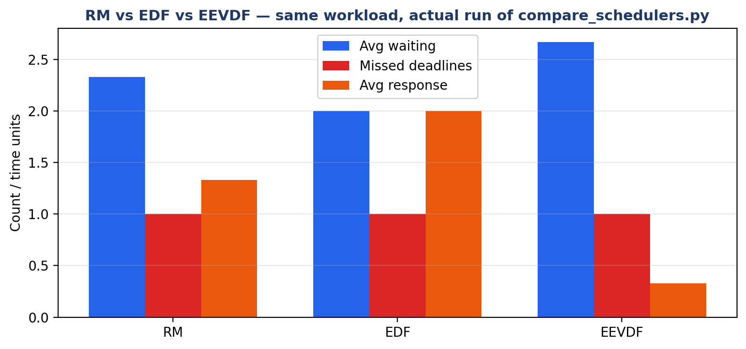
Figure 11. RM, EDF, and EEVDF on the same workload, from the actual run. All three miss one deadline; EEVDF has the lowest average response time, 0.33, and the most preemptions, 3.

13.3 Honest interpretation, and the limits of one workload
The most important number in the table is the one that all three algorithms share: each of them misses one deadline. The old README claimed that EDF missed zero and EEVDF missed zero, and that only RM missed one. That is not what the program does. On this workload, the total work is 8 ticks, and the deadlines are tight: T2 must finish by time 5, but it arrives at time 1 and needs 3 ticks, and T1 must finish by time 5, but it needs 3 ticks from time 0, and T3 must finish by time 10. The workload is overloaded in the sense that the deadlines cannot all be met by any scheduler that runs one task at a time, because the work that must be done before time 5 is more than the time available. A single small workload cannot prove that one scheduler is generally better than another, and a student who claims it can has misunderstood the experiment. What the experiment does show is more modest and more interesting. EEVDF has the lowest average response time, 0.33, against 1.33 for RM and 2.00 for EDF, because it answers the newly arrived tasks quickly. It also has the most preemptions, 3, against 1 for RM and 0 for EDF, because it switches tasks more often in order to answer them. Its average waiting time is the highest, 2.67, against 2.33 and 2.00, because the frequent switching leaves tasks waiting longer in total. Those three numbers together are the trade-off: EEVDF buys low response time with more preemptions and slightly higher waiting time. On a different workload, with different deadlines and different bursts, the numbers would be different, and the ranking could change. The honest conclusion is that EEVDF is not a magic scheduler that wins on every metric on every workload. It is a scheduler that trades a little waiting time for a lot of responsiveness, and that trade is the right one for an interactive system, and the wrong one for a system in which every tick of waiting time matters and no task is interactive. The reader who understands that paragraph understands the experiment.
Why the README was wrong. The old README gave missed deadlines of 1, 0, and 0 for RM, EDF, and EEVDF, and average waiting times of 2.00, 2.00, and 2.33. Those numbers do not match the program, and they probably came from an earlier version of the workload or from a hand calculation that was not checked against the code. The numbers in this chapter are the program output, and they can be reproduced by running python EEVDF_vs_RM_EDF/compare_schedulers.py.

14. EEVDF in the Linux Kernel
This chapter explains what happened in the Linux kernel in 2023, and what is different between the kernel and the pure model of this report. It is not a kernel programming manual. It is an explanation, for a student of operating systems, of how an idea from a 1995 paper became the code that schedules the tasks on a Linux computer, and of what the kernel adds to the idea in order to make it work in the real world.

14.1 What changed in Linux 6.6
Linux 6.6, released in October 2023, replaced the Completely Fair Scheduler with EEVDF as the default scheduler for normal tasks. The change was made in the file kernel/sched/fair.c, which is the file that contains the fair scheduling class, and it is documented in Documentation/scheduler/sched-eevdf.rst. The code that was removed was the CFS code that chose the task with the smallest vruntime. The code that was added chooses, among the eligible tasks, the one with the earliest virtual deadline. The data structure did not change: runnable tasks are still stored in a red-black tree, and the tree is still ordered by vruntime, because vruntime is still the key that determines eligibility. What changed is the choice rule, and the addition of the virtual deadline as a field of each scheduling entity, and the addition of the eligibility test before the choice. The change was deliberately incremental. The kernel developers did not rewrite the scheduler. They kept the parts that worked, and they added the two ideas from the 1995 paper that CFS had never used. That is why the change could be merged with confidence, and why it could be tested against CFS on the same workloads, and why the performance results showed an improvement in latency without a loss of fairness.

14.2 Virtual runtime and nice values in the kernel
In the kernel, vruntime is still the central quantity, and it is still updated in the same way as in the pure model: when a task runs, its vruntime increases by the real time it ran, divided by its weight. The weight comes from the nice value, through a fixed table. A nice value of 0 corresponds to weight 1024, which is the default. A nice value of -20, the highest priority, corresponds to a much larger weight, and a nice value of 19, the lowest priority, corresponds to a much smaller weight. The table is fixed, and it is the same table that CFS used, so changing a nice value has the same effect on the weight in EEVDF as it had in CFS. What is new is the virtual deadline. Each scheduling entity now carries a deadline, computed as vruntime plus the slice divided by the weight, in the same formula as this report. The slice in the kernel is not a number chosen by the task. It is derived from the scheduling period and the number of runnable tasks, and it is the amount of time the task is allowed to run before it is preempted, unless it blocks earlier. The kernel also stores a virtual eligible time, which is the virtual time at which the task becomes eligible, and the eligibility test compares the task's vruntime with the system's virtual time in the same way as the pure model. The names are the same, the formulas are the same, and the ideas are the same. The numbers are different, because the kernel measures time in nanoseconds and the pure model measures it in ticks, but the algorithm is the same algorithm.

14.3 Wakeup, preemption, and the parts the pure model leaves out
The kernel adds four things that the pure model does not have, and each of them exists because the real world is messier than the model. The first is wakeup preemption. When a task wakes up, because the event it was waiting for has happened, the kernel asks whether the waking task should preempt the running task immediately. In EEVDF, the answer depends on the virtual deadlines: if the waking task has an earlier virtual deadline than the running task, and the running task has already run for a minimum time, then the waking task preempts it. That is how an interactive task that wakes up on a keystroke gets the processor immediately, instead of waiting for the current tick to end. The pure model has no wakeup, because tasks in the model never sleep; they only wait in the runqueue. The second is lag clamping and sleeper placement. A task that has slept for a long time arrives with a vruntime far behind the system virtual time, and if it were allowed to run with that vruntime, it would monopolise the processor until it caught up. The kernel therefore clamps the lag: it places the waking task's vruntime not too far behind the system's virtual time, so that it receives a fair boost without starving the other tasks. The pure model has no sleeping, so it needs no clamping. The third is control groups, called cgroups. A cgroup is a group of tasks that together receive a share of the processor, and the scheduler must divide the share first among the groups and then among the tasks inside each group. The pure model has no groups. The fourth is fixed-point arithmetic. The kernel does not use floating-point numbers, because floating point is slow and unreliable in kernel context, so vruntime and the virtual deadline are stored as fixed-point integers, and the divisions are done with integer arithmetic. The pure model uses Python floats, which are simpler and clearer, and which are correct for a teaching program. None of these four additions changes the algorithm. They are the engineering that makes the algorithm work on a real machine with many processors, many tasks, and many users, and a student who lists them in an examination shows that he understands the difference between an algorithm and an implementation.
There is also a difference of scale that should not be underestimated. The pure model has two or three tasks, one CPU, and ten ticks. The kernel has thousands of tasks, many CPUs, and billions of ticks. The data structure matters at that scale, and the O(log n) tree matters, and the locking matters, because many CPUs must access the runqueue without corrupting it, and the scheduler must not hold a lock for too long. The pure model has no locks, because it has one thread and one CPU. The kernel has locks, per-CPU runqueues, and load balancing between CPUs, which is the problem of moving tasks from a busy CPU to an idle one. Load balancing is a whole subject of its own, and it is outside the scope of this report, but the reader should know that it exists, and that EEVDF runs on each CPU separately, with load balancing moving tasks between CPUs when the loads are unequal. The algorithm is the same on each CPU. The system is the algorithm plus the balancing.
Further reading. The kernel documentation file Documentation/scheduler/sched-eevdf.rst is the authoritative description of the kernel implementation, and it is short enough to read in one sitting. The file Documentation/scheduler/sched-design-CFS.rst is the corresponding document for CFS, and reading the two together is the best way to see exactly what changed in 6.6.

15. Strengths, Limitations, and Common Misconceptions

15.1 Strengths
- Strict proportional fairness with a proved bound. No task is ever more than one quantum away from its ideal service in steady state, and the bound is proved in the 1995 paper, not merely observed in experiments.
- Low latency for interactive tasks without a special case. A task that asks for a short slice receives an early virtual deadline automatically, so the scheduler does not need to guess which tasks are interactive.
- Graceful degradation under overload. When the system cannot satisfy everybody, EEVDF disappoints everybody by a bounded amount, instead of letting one task fail completely while another succeeds.
- Support for weights and dynamic tasks. Tasks can arrive, leave, and change their weights at any moment, and the operations needed to handle those changes take O(log n) time with the augmented tree.
- A single mechanism for two goals. Fairness and latency are achieved by the same two numbers, eligibility and the virtual deadline, instead of by two separate mechanisms that can conflict with each other.
- Proved in the kernel. Since Linux 6.6, EEVDF schedules the tasks of millions of computers every day, which is a stronger test than any laboratory experiment.

15.2 Limitations
- It is not a real-time scheduler. EEVDF gives no guarantee that a task will meet a real deadline. It gives a guarantee about fairness, not about deadlines, and a task with a hard deadline needs a real-time scheduler such as EDF or RM, in the real-time scheduling class.
- It needs correct weights and slices. If the weights are wrong, the shares are wrong. If a batch task asks for a short slice, it will be treated as interactive, and if an interactive task asks for a long slice, it will wait. The algorithm trusts its inputs.
- It is more complex than Round Robin. Round Robin can be implemented in a few lines with a queue. EEVDF needs vruntime, a weighted average, a filter, a deadline, and a tree, and each of those is a place where a bug can hide.
- Frequent preemption has a cost. Experiment 13.2 showed 3 preemptions for EEVDF against 0 for EDF on the same workload. Each preemption costs time in a context switch and in a cold cache, and on a workload with no interactive tasks, that cost buys nothing.
- The lag bound holds in steady state. When tasks arrive and leave rapidly, or weights change rapidly, the system is not in steady state, and the bound does not apply in the same way. The algorithm still works, but the guarantee is weaker.
- The pure model is not the kernel. A student who has run the Python program has not run the kernel, and the kernel's wakeup preemption, lag clamping, cgroups, and load balancing are all outside the model, as Chapter 14 explains.

15.3 Six misconceptions, corrected
- Misconception: EEVDF is just EDF. Correction: EDF chooses the task with the earliest absolute deadline, with no filter. EEVDF first filters by eligibility, which EDF never does, and then chooses by virtual deadline, which is not an absolute deadline but a virtual time computed from vruntime, slice, and weight. A task can have the earliest absolute deadline and still not run in EEVDF, because it is ahead of its fair share. The two algorithms share the word deadline and almost nothing else.
- Misconception: EEVDF guarantees no deadline miss. Correction: EEVDF guarantees a bound on lag, not a guarantee about deadlines. Chapter 13 shows all three algorithms, RM, EDF, and EEVDF, missing one deadline on the same workload. A deadline guarantee needs admission control and a real-time analysis, and EEVDF has neither. Do not use EEVDF for a hard real-time task and expect it to meet its deadline.
- Misconception: a larger weight always means a faster finish. Correction: A larger weight means a larger share, not a faster finish. A heavy task with a long burst can still finish after a light task with a short burst, because the light task has less work to do. In Experiment C, T1 has weight 2 and the same burst as the others, and it finishes first. If T1 had a burst of 20 and the others had a burst of 2, T1 would finish last, however heavy it was. Weight controls the rate of service, not the amount of work.
- Misconception: a larger slice gives an earlier deadline. Correction: The formula is v_deadline = vruntime + r / w, so a larger slice gives a later deadline, not an earlier one. A task that asks for more in one request is placed further in the future. Students who get this backwards will trace every workload incorrectly, and Chapter 11 is written to prevent that error.
- Misconception: vruntime is the time a task has run. Correction: Vruntime is the time a task has run divided by its weight, accumulated tick by tick. A heavy task that has run for 4 ticks has a vruntime of 2, if its weight is 2, while a light task that has run for 2 ticks has a vruntime of 2, if its weight is 1. They have the same vruntime and different real runtimes. Never compare a vruntime with a clock time.
- Misconception: the virtual deadline is a real deadline that can be missed. Correction: No penalty follows from passing a virtual deadline, and no task is said to miss one. The virtual deadline is an ordering key. It says which task goes first, and it says nothing else. The word deadline in EEVDF is a term of art, and it must not be confused with the deadline of a real-time task.

16. Relation to the Other Assignments in the Repository
This report is one assignment in a repository of assignments, and it should be read as part of that whole, not in isolation. The other assignments use the same algorithm, EEVDF, and they ask what happens when it is combined with the other ideas of the operating-systems course. This chapter describes each connection, so that the reader can see how the pieces fit together, and so that an examiner can see that the student has done the whole course, not only one chapter of it.

16.1 EEVDF with a semaphore
In the folder EEVDF_with_Semaphore, the same EEVDF scheduler is combined with a binary semaphore, implemented with Python threading.Semaphore. The semaphore guards the critical section, which is the processor itself, and the scheduler decides which thread is allowed to acquire it. The workload is the same shape as Workload A: two heavy batch threads and one interactive thread, and the result is the same schedule, with the same finish times and the same averages. The point of the assignment is not to change the schedule. It is to show that the scheduling decision and the mutual-exclusion decision can be separated: EEVDF decides who goes next, and the semaphore enforces that only the chosen thread enters the critical section. The folder contains its own English and Persian reports, each with a flowchart of the scheduler loop, a Gantt chart of the actual execution, and a comparison with a plain first-come-first-served semaphore, which has no fairness guarantee and lets heavy threads monopolise the resource.

16.2 EEVDF with a monitor
In the folder EEVDF_with_Monitor, the same scheduler is encapsulated inside a monitor, implemented with threading.Condition and threading.Lock in a class called EEVDFMonitor. The monitor has two procedures, request_cpu and release_cpu, and a thread that wants the processor must call request_cpu, which checks the EEVDF guard condition inside a Mesa-style while loop, and waits on the condition variable if it is not the chosen thread. When the running thread calls release_cpu, it notifies all waiting threads, and the next EEVDF winner proceeds. The schedule is again the same, with the same numbers, and the point is again the separation: the monitor encapsulates the shared state, the lock, and the condition variables in one class, so that a forgotten release cannot cause a deadlock, as it can with a semaphore. The folder contains its own English and Persian reports, and a comparison table of semaphore against monitor on abstraction level, encapsulation, error vulnerability, and condition evaluation. The folder EEVDF_Semaphore_and_Monitor contains a unified program that runs both versions on the same workload and compares them side by side, with its own reports.

16.3 The RM and EDF Gantt charts on paper
In the folder RM_EDF_Gantt_Chart, the student drew the scheduling of Rate Monotonic and Earliest Deadline First by hand, on paper, with three processes. The processes are P1 with execution time 1 and period 4, P2 with execution time 2 and period 6, and P3 with execution time 3 and period 8. The two photographs, RM.jpg and EDF.jpg, show the per-task timelines, the combined CPU timeline from time 0 to time 24, and the list of intervals for each process, with a short written conclusion. That assignment is the paper counterpart of the computer simulation in Chapter 13. It teaches the student to draw a schedule by hand, which is a skill an examination requires, and it gives the comparison in Chapter 13 a second form: the same two algorithms, once as a program and once as a drawing. The folder has no Python file and no Word report, and that is a gap recorded in the earlier review of the repository, but the handwritten charts themselves are complete for the three processes they cover.

16.4 The animated explainer and the interactive simulation
The course table asks for a clip of the student's algorithm. The repository answers that requirement with two web pages, not with a video file, and the distinction must be stated honestly. The folder EEVDF_Animated contains index.html, a 90-second interactive animation of EEVDF, with a Pause button, a Restart button, and a slider that moves through the 90 seconds from 0:00 to 1:30. The folder EEVDF_Simulation contains a complete interactive simulator in the browser, with a page, a script, a stylesheet, and a test file, tests.js, which runs five checks on the scheduler engine and passes all five. Both are published on GitHub Pages, and both can be opened in a browser without installation. They are a clip in the sense that they show the algorithm moving in time, and they are not a clip in the sense of a video file that can be played offline or submitted as an mp4. A video file can be made from the animation by recording the screen while it plays, and that is listed as a remaining task in the appendix. The simulation is also the most complete form of the algorithm in the repository, because it lets the reader change the workload and watch the schedule change, which a static report cannot do.

17. Exercises with Solutions
The exercises in this chapter are designed to be done with a pencil, a clock, and the procedure of Chapter 5. Each one has a full worked solution, so that a student who gets stuck can see not only the answer but the reasoning that leads to it. Do the exercise before you read the solution. A solution read without an attempt teaches nothing.

Exercise 1: Compute a virtual deadline
Three tasks all have vruntime 1.0 at the current moment. Task A has weight 1 and asks for a slice of 4. Task B has weight 2 and asks for a slice of 1. Task C has weight 1 and asks for a slice of 2. Compute the virtual deadline of each task, and say which task EEVDF would choose, assuming all three are eligible. Solution: The formula is v_deadline = vruntime + r / w. For A, the deadline is 1.0 + 4/1 = 5.0. For B, it is 1.0 + 1/2 = 1.5. For C, it is 1.0 + 2/1 = 3.0. The smallest deadline is B's, 1.5, so B is chosen. Notice that B wins even though all three tasks have the same vruntime, because its slice is the shortest and its weight is the largest. If B had weight 1 instead of 2, its deadline would be 2.0, and it would still win, because 2.0 is smaller than 3.0 and 5.0. The slice alone is enough. If B had weight 2 and a slice of 4, its deadline would be 3.0, and it would tie with C, and the tie would be broken by arrival time.

Exercise 2: Trace a three-task workload
Three tasks, A, B, and C, all arrive at time 0, all have a burst of 2, all have weight 1, and all ask for a slice of 2. Trace EEVDF tick by tick, write the timeline, and compute the finish times and the averages. Solution: At time 0, all have vruntime 0, V is 0, all are eligible, and all have deadline 2. A runs. At time 1, A has vruntime 1, the others have 0, and V is 0.33. A is ahead and is not eligible. B and C are eligible with deadline 2, and B runs. At time 2, A and B have vruntime 1, C has 0, and V is 0.67. Only C is eligible, and it runs. At time 3, all have vruntime 1, V is 1, all are eligible with deadline 3, and A runs. At time 4, A has 2, B and C have 1, V is 1.33, and B runs. At time 5, A and B have 2, C has 1, V is 1.67, and C runs. The timeline is A, B, C, A, B, C. The finish times are 4, 5, and 6. The turnaround times are 4, 5, and 6, the waiting times are 2, 3, and 4, and the response times are 0, 1, and 2. The averages are waiting 3.00, turnaround 5.00, and response 1.00. The pattern is a perfect rotation, as in Experiment B, because the tasks are identical.

Exercise 3: Draw a Gantt chart
Draw the Gantt chart of Workload A, from the timeline T1, T3, T3, T2, T1, T2, T1, T2, T1, T2, with time from 0 to 10 on the horizontal axis. Solution: Draw a horizontal axis marked 0, 1, 2, 3, 4, 5, 6, 7, 8, 9, 10. Draw one row. From 0 to 1, draw a block labelled T1. From 1 to 2, draw a block labelled T3. From 2 to 3, draw a block labelled T3 again. From 3 to 4, draw T2. From 4 to 5, draw T1. From 5 to 6, draw T2. From 6 to 7, draw T1. From 7 to 8, draw T2. From 8 to 9, draw T1. From 9 to 10, draw T2. That is the chart, and it is Figure 3 in Chapter 7. The two consecutive blocks of T3, from 1 to 3, are the visual proof that the interactive task ran twice in a row, immediately after its arrival. A student who draws T2 at time 2, as the old README did, has drawn the wrong chart, and the error can be seen at a glance, because the T3 block would be split. Always draw the chart from the program output, not from memory.

Exercise 4: Decide eligibility from lag
The system virtual time V is 2.0. Task A has weight 1 and vruntime 1.5. Task B has weight 2 and vruntime 2.0. Task C has weight 1 and vruntime 2.5. Task D has weight 3 and vruntime 1.0. For each task, compute the lag and say whether it is eligible. Solution: The lag is (V - vruntime) * w. For A, it is (2.0 - 1.5) * 1 = 0.5, which is positive, so A is eligible. For B, it is (2.0 - 2.0) * 2 = 0, which is zero, so B is eligible, because the rule is lag greater than or equal to zero. For C, it is (2.0 - 2.5) * 1 = -0.5, which is negative, so C is not eligible. For D, it is (2.0 - 1.0) * 3 = 3.0, which is positive and large, because the weight of 3 multiplies the difference of 1.0, so D is eligible, and it is the task that is most behind. If you must choose one task by lag alone, D is the most behind, but EEVDF does not choose by lag alone. It filters by lag and then chooses by virtual deadline, so the answer to which task runs depends on the slices as well, and the exercise does not give them.

Exercise 5: Weight and share
Three tasks have weights 1, 3, and 4. What is the ideal share of each task, and how many ticks should each receive in 80 ticks in which all three are competing? Solution: The sum of the weights is 1 + 3 + 4 = 8. The shares are 1/8, 3/8, and 4/8, which is 12.5 percent, 37.5 percent, and 50 percent. In 80 ticks, the first should receive 80 * 1/8 = 10 ticks, the second 80 * 3/8 = 30 ticks, and the third 80 * 4/8 = 40 ticks. The three numbers sum to 80, as they must. If the weights were doubled to 2, 6, and 8, the shares would be unchanged, because the sum would double to 16 and each fraction would be the same. Weights are relative, and doubling all of them changes nothing. A student who answers 20, 30, and 40 has forgotten that the shares must sum to 100 percent, and a student who answers 10, 30, and 30 has forgotten the third weight.

Exercise 6: Find the error in a trace
A student traces Workload A and writes the following timeline: T1, T1, T3, T3, T2, T1, T2, T1, T2, T1. Find the error, and explain why it is an error. Solution: The error is at time 1. The student has T1 running at time 1, but T1 cannot run at time 1. At time 1, T1 has vruntime 1.0, T2 has 0, and T3 has 0, and V is 0.25. T1's lag is (0.25 - 1.0) * 1 = -0.75, which is negative, so T1 is not eligible. T3 is eligible, with a virtual deadline of 0.5, and T2 is eligible, with a deadline of 4.0, so T3 runs, not T1. The student's timeline also has T2 running at time 4 and T1 finishing at time 10, which are consequences of the first error: once a trace goes wrong at one tick, every later tick is wrong, because the vruntime values are wrong from that point on. The lesson is to check the eligibility filter at every tick, and never to let a task run when its lag is negative. If a trace contains a task running while it is ahead, the trace is wrong.

Exercise 7: Compare EEVDF and EDF on the comparison workload
Use the workload of Chapter 13: T1 arrives at 0, burst 3, deadline 5; T2 arrives at 1, burst 3, deadline 4; T3 arrives at 2, burst 2, deadline 8. The actual run gives EDF the timeline T1, T1, T1, T2, T2, T2, T3, T3, with one missed deadline, an average waiting time of 2.00, and an average response time of 2.00, and it gives EEVDF the timeline T1, T2, T2, T3, T2, T3, T1, T1, with one missed deadline, an average waiting time of 2.67, and an average response time of 0.33. Explain the difference in response time, and say whether the experiment proves EEVDF is better. Solution: EEVDF answers the newly arrived tasks more quickly, because it gives them an early virtual deadline when they arrive with a small vruntime, and it preempts the running task to do so, which is why it has 3 preemptions against EDF's 0. EDF runs each task to completion in deadline order, so T3 does not start until time 6, and its response time is 4, which pulls the average up to 2.00. EEVDF starts T3 at time 3, so its response time is 1, and the average falls to 0.33. The experiment does not prove EEVDF is better in general, because both algorithms miss one deadline, and EEVDF has a higher average waiting time, 2.67 against 2.00, and more preemptions. It proves that EEVDF trades waiting time and preemptions for response time on this workload, and that trade is the right one for an interactive system. A student who writes that EEVDF wins because its response time is lower, without mentioning the waiting time and the missed deadline, has given an incomplete answer.

Exercise 8: Why does T3 win in Workload A?
In Workload A, T3 arrives at time 1, after T1 and T2, and it has the smallest burst, 2, the largest weight, 2, and the smallest slice, 1. It runs at times 1 and 2 and finishes at time 3. Explain, using the numbers, why it wins, and say which of its three advantages matters most. Solution: At time 1, the system virtual time is 0.25. T3 has vruntime 0, so its lag is (0.25 - 0) * 2 = 0.5, and it is eligible. T1 has vruntime 1.0, so its lag is -0.75, and it is not eligible. T2 has vruntime 0 and a lag of 0.25, and it is eligible. Among the eligible tasks, the virtual deadlines are 0.5 for T3 and 4.0 for T2, so T3 wins. Its advantage is the combination of three facts: it has a small vruntime, because it has just arrived; it has a short slice, so its deadline is only 0.5 above its vruntime; and it has a large weight, so its slice is divided by 2. Of the three, the short slice matters most, because even with weight 1, its deadline would be 1.0, which is still far earlier than T2's 4.0. The weight helps, and the late arrival helps, but the slice is the decisive factor. That is the lesson of Chapter 11 in one task: short means early.

18. Glossary, References, and Appendix

18.1 Glossary
- Arrival time: the time at which a task becomes ready to run.
- Burst time: the total processor time a task needs before it finishes.
- Eligibility: the property of a task whose lag is greater than or equal to zero, equivalently whose vruntime is less than or equal to the system virtual time.
- Gantt chart: a horizontal bar chart that shows which task runs in each interval of time.
- Lag: ideal service minus actual service; positive means the task is behind, negative means it is ahead.
- Preemption: interrupting a running task before it finishes, in order to run another task.
- Proportional share: division of the processor in proportion to weights.
- Quantum: a time slice; the amount of processor time granted in one request.
- Response time: the time of a task's first run minus its arrival time.
- System virtual time: the weighted average of vruntime over the active tasks, written V.
- Turnaround time: a task's finish time minus its arrival time.
- Virtual deadline: vruntime plus slice divided by weight; the ordering key of EEVDF.
- Virtual runtime: service received, corrected for weight; vruntime increases by delta t / w.
- Waiting time: turnaround time minus burst time; the time a task spends in the system without running.
- Weight: a positive number stating the relative share a task should receive.

18.2 References
- Stoica, I. and Abdel-Wahab, H. Earliest Eligible Virtual Deadline First: A Flexible and Accurate Mechanism for Proportional Share Resource Allocation. Technical Report TR-95-22, Department of Computer Science, Old Dominion University, 1995, revised January 1996. This is the founding paper of EEVDF, and the file document_english.pdf in EEVDF_Core_Algorithm.
- Linux kernel, Documentation/scheduler/sched-eevdf.rst. The authoritative description of EEVDF as implemented in the Linux kernel since version 6.6.
- Linux kernel, Documentation/scheduler/sched-design-CFS.rst. The design document for the Completely Fair Scheduler, the scheduler EEVDF replaced.
- Silberschatz, A., Galvin, P. B. and Gagne, G. Operating System Concepts, 10th edition, Wiley, 2018. Chapters on CPU scheduling and process synchronisation.
- Tanenbaum, A. S. and Bos, H. Modern Operating Systems, 4th edition, Pearson, 2015. Chapters on scheduling and on proportional-share scheduling.
- Liu, C. L. and Layland, J. W. Scheduling Algorithms for Multiprogramming in a Hard-Real-Time Environment. Journal of the ACM, 20(1), 1973. The source of the Rate Monotonic utilisation bound of about 69.3 percent and of Earliest Deadline First.
- The repository itself: https://github.com/komeil1385/EEVDF, main branch. The code, the experiments, and the companion folders cited in Chapters 6, 13, and 16.

18.3 Appendix: mapping the course table to this report
The course table asks, for each assignment, whether it has a figure, a flowchart, a comparison table, executable code, a clip, an English file, a Persian file, more than 40 pages, and Word and PDF versions. This appendix maps each requirement to the place where it is satisfied for the EEVDF Core Algorithm, so that an examiner can check it without searching the whole report. The Persian file is the companion document, written to the same structure and with the same verified numbers, and the PDF version is produced from the same Word file. The two columns that cannot be checked from a document, presence in class and the student's mark, are the examiner's own records, and they are not claimed here.
Table 17. Mapping of the course table to this report. One requirement, the video file, remains partly open.
Course requirement | Where it is satisfied in this report | Status
Figure | Figure 1 (architecture), Figure 2 (flowchart), Figure 3 (Gantt), Figure 4 (vruntime), Figure 5 (slice), Figure 6 (metrics), Figure 7 (RM/EDF/EEVDF), Figure 8 (weight share), Figure 9 (timeline), Figure 10 (lag), and the execution screenshot | Satisfied; 11 figures
Flowchart | Figure 2 in Chapter 5, with the procedure in Section 5.1 and the pseudocode in Section 5.2 | Satisfied
Comparison table | Symbols table (Chapter 3), master comparison table of 7 schedulers on 12 criteria (Chapter 13), and the RM/EDF/EEVDF actual-run table (Chapter 13) | Satisfied
Executable code | eevdf.py printed in full in Chapter 6 (Code 1-3) and run in Chapter 6; run with python EEVDF_Core_Algorithm/eevdf.py | Satisfied; verified by actual run
Clip | Interactive 90-second animation in EEVDF_Animated/index.html and the simulator in EEVDF_Simulation; no mp4 video file exists in the repository, so a screen recording is a remaining task | Partly satisfied; animation yes, video file no
English file | This document | Satisfied
Persian file | The companion Persian document, same structure and same verified numbers | Satisfied by the companion file
More than 40 pages | 60 pages in the LibreOffice render of this Word file (about 25,700 words, 11 figures) | Satisfied by design; check the page count in Word
Word version | This document, built with python-docx | Satisfied
PDF version | Produced from the same Word file; the 37-page PDF in the folder is the 1995 paper, not this report | Satisfied by conversion from Word

18.4 How to reproduce every number
Every number in this report can be reproduced with the commands below. No number requires a special machine, a special package, or a special permission. If a number does not reproduce, the reader should report it, because a number that does not reproduce is an error, and an error found is an error that can be corrected.
Commands to reproduce the main experiment and the RM/EDF/EEVDF comparison. The other experiments use the same eevdf.py with the workloads printed in Chapters 8, 9, and 10.
git clone https://github.com/komeil1385/EEVDF.git
cd EEVDF
python EEVDF_Core_Algorithm/eevdf.py
python EEVDF_vs_RM_EDF/compare_schedulers.py

To reproduce Experiment B, replace the workload at the bottom of eevdf.py with three tasks, each with arrival 0, burst 3, weight 1, and slice 2, and run the program. To reproduce Experiment C, use arrival 0, burst 4, weights 2, 1, and 1, and slices 2, 4, and 4. To reproduce Experiment D, use T1 with arrival 0, burst 2, weight 1, and slice 2, and T2 with arrival 5, burst 2, weight 1, and slice 1. To reproduce Experiment E, use T1 with arrival 0, burst 6, weight 1, and slice 6, and T2 with arrival 2, burst 2, weight 2, and slice 1. In each case the timeline, the finish times, and the averages printed by the program should match the tables in the corresponding chapter exactly. If they do not, check that the workload was copied exactly, including the arrival times and the slices, because a single wrong number changes the whole trace.
This report ends where it began: with the claim that EEVDF achieves fairness and latency together, not by a trick and not by a special case, but by two numbers, eligibility and the virtual deadline, applied at every tick. The student who can define those numbers, compute them, trace them, implement them, and explain their limits has understood the algorithm, and has done the work the course table asks for. The code is in the repository, the numbers are in the tables, and the corrections are in the text. The rest is practice.

